SAVEETHA
INSTITUTE OF MEDICAL AND TECHNICAL SCIENCES
CSA15 – CLOUD COMPUTING AND BIG DATA ANALYTICS

ASSIGNMENT 2 – CO2
Analyse, Evaluate and Validate a Virtualization Architecture
for a Multi-Tenant University Private Cloud
CO2: Analyze virtualization architectures to identify performance and security issues in cloud computing environments.

Field | Details | Field | Details
Student Name | P.Gowtham Reddy | Registration Number | 192525139
Department / Section | Not specified in the assignment brief | Academic Year / Semester | 2026
Faculty Name | Dr. R. Latha | Nature of Assignment | Individual
Duration | 1 Week | Total Marks | 50
Submission Date |  | Evaluation Date

MARK SHEET (Rubric-based evaluation)
Task | Title | Max | Evidence / evaluation focus
1 | Characterise the Virtualization Architectures | 5 | Layered diagrams; trust boundaries; resource virtualization
2 | Identify the Dominant Overhead Source | 2 | Architecture-specific bottleneck and scaling behaviour
3 | Build a Quantitative Performance Model | 6 | CPU, memory, I/O, network and density derivations
4 | Analyse Performance Under Operating Conditions | 4 | Best, typical and worst-case reasoning
5 | Security Threat and Vulnerability Analysis | 3 | Threat model, exposure and CIA impact
6 | Isolation–Performance Trade-off | 3 | Variables, objectives, constraints and decision function
7 | Evaluate Mitigation Strategies | 4 | At least three mitigations with residual risk and cost
8 | Implement and Test | 4 | Reproducible setup, commands and test plan
9 | Record Experimental Performance | 3 | Tables, graphs, repeated measurements and variability
10 | Compare Theory with Experiment | 4 | Prediction-versus-measurement and error analysis
11 | Recommend and Defend Final Architecture | 4 | Performance, security, cost and operational justification
12 | Day-4 Design Challenge | 8 | Big-data workload impact, redesign and evidence-based defence
 | TOTAL | 50

EVIDENCE VERIFICATION CHECKLIST
Tasks | Evidence expected | Status (✓ / P / ✗) | Evaluator note
1 | Three distinct architectures, diagrams and trust boundaries | P | Diagrams and conceptual analysis included; deployment verification required
2–4 | Overhead analysis, quantitative model and operating-condition analysis | P | Analytical assumptions and worked examples documented
5–7 | Threat model, trade-off formulation and mitigations | P | Security analysis and estimated performance costs documented
8–10 | Reproducible tests, measured data, graphs and theory comparison | P | Commands and result templates supplied; actual measurements must be inserted
11–12 | Final recommendation and Day-4 redesign | P | Recommendation is based on analytical model; validate with local experiments

IMPLEMENTATION EVIDENCE CHAIN
Evidence item | Status | Observation
Architecture diagrams | ✓ | Three architecturally distinct approaches illustrated
Analytical performance model | ✓ | CPU, memory, network and density calculations shown
Threat and mitigation analysis | ✓ | Architecture-specific risks and controls evaluated
Test environment | P | Reproducible setup and commands provided; run locally to generate evidence
Experimental measurements | P | No results are represented as measured; record actual repeated runs
Screenshots and logs | P | Insert authentic terminal, dashboard and test screenshots after execution

OVERALL REMARKS
This report presents an analytical design and a reproducible experimental procedure for EduCloud. Numerical outputs identified as model estimates or illustrative calculations are not claimed to be measured results. The experimental tables are provided for recording genuine observations from the test environment.

CLOUD COMPUTING AND BIG DATA
ASSIGNMENT 2
CO2: Analyze virtualization architectures to identify performance and security issues in cloud computing environments.
_________________________________________________________________
Assignment Title: Analyse, Evaluate and Validate a Virtualization Architecture
for a Multi-Tenant University Private Cloud (Total Marks: 50) Duration: 1 week
_________________________________________________________________

Scenario: EduCloud Virtualization Platform
A university runs a private cloud, EduCloud, in its data centre. EduCloud currently consists of:
- 16 physical hosts, each with 64 CPU cores, 512 GB RAM, NVMe SSD storage and 2 × 25 Gbps NICs
- About 400 virtual machines (VMs) running the Student Information System (SIS), the Learning Management System (LMS), the examination portal, and departmental research workloads
- A shared storage backend and a software-defined virtual network
During semester registration week, users report slow response times and failed logins. A recent internal security audit also found that VMs from different departments share the same physical hosts, that some VMs run outdated guest kernels, and that VM images are copied freely between teams.
You are the cloud architect. You must investigate, model, measure and compare virtualization architectures for EduCloud, identify their performance bottlenecks and security weaknesses, and recommend a design that remains practical as the platform grows.
Design Challenge:
The university now plans to host external research collaborators' big-data workloads (Spark/Hadoop clusters) on the same infrastructure as the SIS.
Re-evaluate your design under these new multi-tenant conditions.

TASK 1: Characterise the Virtualization Architectures (5 Marks)
Select at least three meaningfully different virtualization approaches from the following, or justify others:
- Type-1 (bare-metal) hypervisor with full virtualization
- Type-2 (hosted) hypervisor
- Hardware-assisted virtualization vs. paravirtualization
- OS-level virtualization (containers)
- Lightweight/micro-VM or sandboxed container runtimes
Two configurations of the same hypervisor will not count as different approaches. Your selection must include at least one VM-based and at least one container-based approach.
For each approach, provide:
- A layered architecture diagram showing the hardware, host OS or hypervisor, guest OS, runtime and application
- The trust boundaries and the component that enforces isolation
- How CPU, memory, storage and network are virtualized
- A brief justification for why this approach is relevant to EduCloud
Evidence expected: Three architecturally distinct approaches with labelled diagrams, resource-virtualization mechanisms, trust boundaries, and justification of
selection.

TASK 2: Identify the Dominant Overhead Source (2 Marks)
For each approach, identify the primary source of performance overhead that predominantly limits its performance (for example VM exits/traps, nested or extended page-table walks, virtual I/O emulation, virtual switch processing, or system-call interception).
Discuss:
- What the overhead source is
- Where in the architecture it occurs
- Why it is appropriate as the focus of performance analysis
- How its frequency or cost changes as the number of co-located VMs/containers or the I/O rate increases
Do not simply name a mechanism. Relate it to the behaviour of the architecture.
Evidence expected: A justified dominant-overhead identification for each approach,
linked to its resource-virtualization path.

TASK 3: Build a Quantitative Performance Model (6 Marks)
Using the following host parameters, develop an analytical performance model for each approach.
Parameter | Value
Physical cores per host | 64
vCPU:pCPU overcommit ratio | 1:1, 2:1, 4:1, 8:1
RAM per host | 512 GB
Average VM memory demand | 8 GB
Cost of one VM exit (assume) | 1.5 µs
Native system-call cost (assume) | 0.2 µs
Network line rate | 25 Gbps

State and justify any additional assumptions. Derive expressions for:
- CPU: effective per-VM CPU capacity as a function of overcommit ratio and virtualization overhead (including steal time)
- Memory: the maximum number of VMs per host before ballooning, swapping or page-sharing becomes necessary
- I/O and network: effective throughput as a function of the number of VMs sharing the physical device
- Density: the number of VMs/containers a host can support while meeting a stated service-level target (for example, ≤ 10% performance degradation)
Show the mathematical reasoning. Merely quoting overhead percentages from the literature will not receive full credit.
Evidence expected: A clear mathematical derivation for each approach, with stated assumptions, parameter values and worked numerical examples.

TASK 4: Analyse Performance Under Different Operating Conditions (4 Marks)
Analyse how each approach behaves under three conditions:

Best case: what workload and placement conditions minimise overhead?
- Typical case: for example, registration-week mixed web and database load
- Worst case: for example, noisy-neighbour interference, memory overcommit with swapping, live migration during peak load, or I/O storms
For each, explain what happens inside the virtualization layer, why the overhead changes, and how latency and throughput are affected. A table of numbers alone will not be accepted.
Evidence expected: A justified condition-based analysis supported by your Task 3
model.

TASK 5: Security Threat and Vulnerability Analysis (3 Marks)
Construct a threat model for each approach. Discuss:
- The attack surface (hypervisor, device emulation, shared kernel, management plane, VM images and snapshots, virtual network)
- At least four distinct threat categories, such as VM escape, cross-VM side-channel attacks, hypervisor or container-runtime vulnerabilities, VM sprawl and unpatched guests, image tampering, insecure live migration, and virtual-network sniffing or spoofing
- For each threat, which approach is more or less exposed and why, referring to its architecture and trust boundaries
- The likely impact on the confidentiality, integrity and availability of student records
Evidence expected: A structured threat model mapped to architectural features,
with a justified comparison across approaches.

TASK 6: Formulate the Isolation–Performance Trade-off (3 Marks)
Formalise the trade-off between isolation strength and performance/density for EduCloud.
Clearly identify:
- The decision variables (for example, approach chosen, VMs per host, dedicated vs. shared hosts, SMT on/off)
- The objective(s), such as maximising density or minimising cost
The constraints (for example, performance degradation limit, isolation requirement for SIS, available hosts)
- How these components combine into a cost or decision function
The formulation must follow from your own analysis in Tasks 3 and 5, not from a generic template.
Evidence expected: A clearly defined trade-off model with identified variables,
objective and constraints.

TASK 7: Evaluate Mitigation Strategies (4 Marks)
Propose at least three mitigations for the vulnerabilities identified in Task 5. Examples include disabling SMT, kernel page-table isolation, dedicated hosts for sensitive tenants, secure or sandboxed container runtimes, hardware memory encryption, image signing, and micro-segmentation.
For each mitigation, discuss:
- Why it is applicable to the threat
- What residual risk remains
- The performance or density cost, estimated using your Task 3 model
- Whether the trade-off is acceptable for the SIS
Evidence expected: Mitigations evaluated analytically, with their security benefit and quantified performance cost.

TASK 8: Implement and Test (4 Marks)
Build a test environment and experimentally test all selected approaches.
- Platforms: use any open-source stack, for example KVM/QEMU, Xen or VirtualBox, Docker/Podman, and Kata Containers or gVisor. Nested virtualization on a laptop is acceptable if documented.
- Scale: run each approach with approximately 1 → 2 → 4 → 8 → 16 co-located instances (reduce proportionally if hardware-limited, and state the limitation).
- Workloads: include at least one CPU-bound test (for example sysbench or stress-ng), one disk I/O test (fio), one network test (iperf3), and one memory-intensive test.
- Interference test: run at least one noisy-neighbour experiment.
Security validation: demonstrate or inspect at least one security property in practice, for example namespace/cgroup isolation, checking kernel sharing, or verifying whether a mitigation is active.
Ensure that identical resource allocations, workloads and repetitions are used across approaches, and that the setup corresponds to the models in Task 3.
Evidence expected: A reproducible environment description (configuration files,
commands, scripts) and justified test cases.

TASK 9: Record Experimental Performance (3 Marks)
Collect and present data such as:
- Throughput, latency (mean and 95th percentile), CPU steal time, context switches and VM exits where observable
- Instance start-up time and memory footprint per instance
- Performance degradation versus a bare-metal baseline
- Results with and without at least one security mitigation
Present at least one table and two graphs (for example, throughput versus number of instances, and latency under interference). Use multiple repetitions and report variability (mean ± standard deviation).
Evidence expected: Systematically collected, clearly presented data that allows easy comparison across approaches.

TASK 10: Compare Theory with Experiment (4 Marks)
Compare your Task 3 and Task 4 predictions with Task 9 measurements.
Discuss:
- Whether the observed degradation trends agree with your model
- Which approach scales better as co-located instances increase
- Quantitative differences between predicted and measured values, and plausible causes (for example caching effects, hypervisor scheduler behaviour, nested virtualization, laptop hardware, or unmodelled I/O paths)
- Whether any measured result changes your security conclusions from Task 5
Interpret the results; do not simply reproduce tables.
Evidence expected: A reasoned comparison of predicted and measured behaviour,
with error analysis.

TASK 11: Recommend and Defend the Final Architecture (4 Marks)
Recommend the virtualization architecture (or hybrid) for EduCloud's SIS and LMS workloads.
Discuss:
- Which approach you recommend and why it is more appropriate than the alternatives
- Its modelled and experimentally observed performance
- Its security posture and residual risks
- Operational costs such as patching, image management, migration and monitoring
- Limitations and trade-offs
- Whether it remains practical as EduCloud grows from 400 to several thousand instances
Your recommendation must rest on your own analysis and experiments. Choosing "the most secure" or "the fastest" option alone is not sufficient.
Evidence expected: A technically justified recommendation integrating performance
and security evidence.

DAY-4 DESIGN CHALLENGE
TASK 12: Re-evaluate and Adapt the Design (8 Marks)

Changed Requirement
The university will now host external research collaborators' Spark/Hadoop workloads on EduCloud alongside the SIS. The new conditions are:
- Big-data jobs are I/O- and network-intensive and run for hours
- Registration-week peak load is about 3× normal
- Hosts are sometimes patched using live migration of running VMs
- A data-protection regulation now requires demonstrable isolation of student records from external tenants
You may RETAIN → MODIFY → or REDESIGN your original solution.

A. Impact Analysis (2 Marks)
Discuss what has changed, which original assumptions (trusted tenants, workload mix, I/O profile) no longer hold, and how mixing batch big-data workloads with latency-sensitive SIS workloads changes both the performance and the threat model.

B. Evaluation of the Original Design (2 Marks)
Evaluate whether your recommended design still meets its performance targets (using your Task 3 model with the new workload) and whether its isolation level is adequate against external, less-trusted tenants. Consider whether another architecture could do better overall.

C. Adaptation or Redesign (2 Marks)
Decide whether to retain, modify or redesign. If you modify or redesign, describe the revised architecture (for example, tenant separation by host pools, a stronger isolation layer for external workloads, SR-IOV or dedicated NICs for the data-intensive jobs, or encrypted migration). Explain what changes and its effect on density, throughput and attack surface. If you retain, justify why no change is required.

D. Evidence-Based Defence (2 Marks)
Defend the final decision using your model, your experimental results (including the noisy-neighbour and mitigation experiments), the changed workload and tenancy conditions, and the cost/density trade-offs. The decision must follow logically from the analysis.

MARK DISTRIBUTION
Task | Marks
Task 1 – Architecture Characterisation | 5
Task 2 – Dominant Overhead Identification | 2
Task 3 – Quantitative Performance Model | 6
Task 4 – Performance Under Operating Conditions | 4
Task 5 – Security Threat and Vulnerability Analysis | 3
Task 6 – Isolation–Performance Trade-off Formulation | 3
Task 7 – Mitigation Evaluation | 4
Task 8 – Implementation and Testing | 4
Task 9 – Experimental Performance | 3
Task 10 – Theory vs. Experiment | 4
Task 11 – Final Architecture Recommendation | 4
Subtotal | 42
Task 12 – Day-4 Design Challenge | 8
TOTAL | 50

SCENARIO – EDUCloud VIRTUALIZATION PLATFORM
EduCloud is a university private cloud with 16 physical hosts. Each host has 64 CPU cores, 512 GB RAM, NVMe SSD storage and two 25 Gbps network interfaces. Approximately 400 VMs support the Student Information System (SIS), Learning Management System (LMS), examination portal and departmental research workloads. The platform uses shared storage and a software-defined virtual network.
During semester registration, users experience slow responses and failed logins. The security audit found that VMs belonging to different departments share physical hosts, some guest kernels are outdated, and VM images are copied freely between teams. The design must therefore improve predictable performance, tenant isolation, patching and image governance without making the private cloud unnecessarily expensive.
The Day-4 challenge adds external research collaborators running Spark/Hadoop workloads on the same infrastructure as SIS. These jobs are I/O- and network-intensive, can run for hours, coincide with a registration-week peak of approximately three times normal load, and may be live-migrated during host patching. Student records must be demonstrably isolated from external tenants.

TASK 1 – CHARACTERISE THE VIRTUALIZATION ARCHITECTURES (5 MARKS)

1.1 Selected architecturally distinct approaches
Three approaches are selected: (A) Type-1 hypervisor with full, hardware-assisted VM virtualization; (B) OS-level virtualization using containers; and (C) lightweight micro-VM or sandboxed-container execution. They are architecturally different and include both VM-based and container-based designs.

Approach A – Type-1 hypervisor with full virtualization
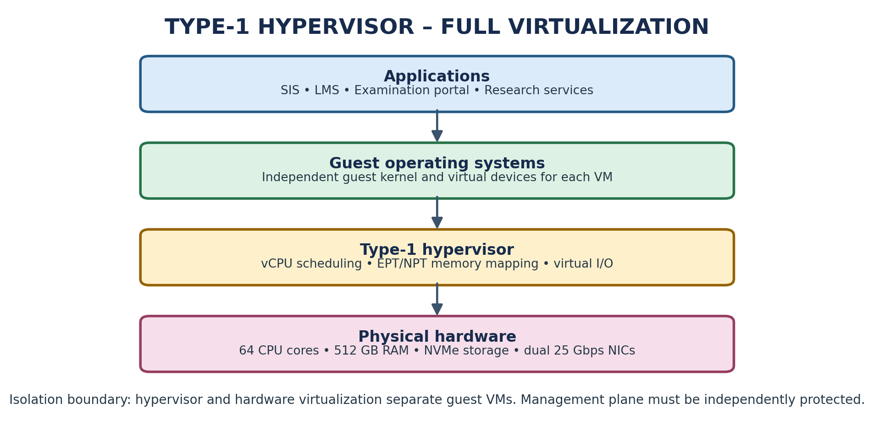
Figure 1: Type-1 hypervisor architecture and trust boundary
A Type-1 hypervisor runs directly on physical hardware. It creates independent virtual machines, each with its own guest operating system. CPU scheduling maps virtual CPUs to physical cores; extended page tables (EPT/NPT) translate guest memory addresses; virtual disks are backed by files, logical volumes or shared storage; and virtual NICs connect to virtual switches. Hardware-assisted virtualization (Intel VT-x/AMD-V) reduces the need for software emulation.
The hypervisor is the main isolation enforcement component. A compromised guest should not directly access another guest's memory or devices. However, the hypervisor, device-emulation code, management API and privileged administrators remain high-value trust boundaries. This approach suits SIS and LMS because separate guest kernels and VM boundaries provide strong isolation for critical, stateful services.

Approach B – OS-level virtualization using containers
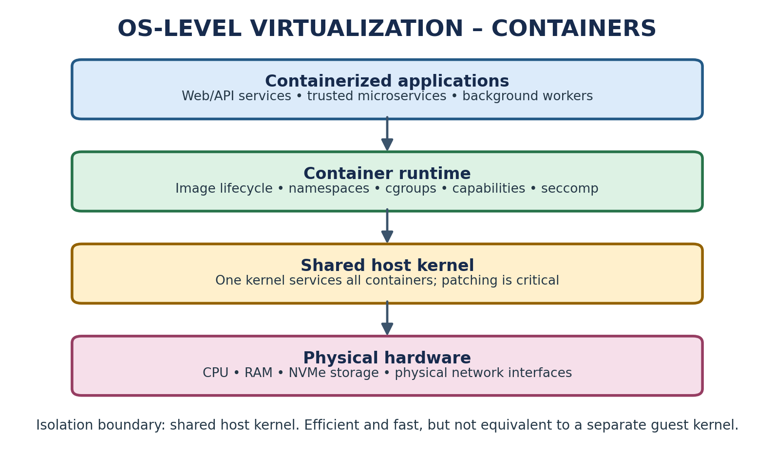
Figure 2: Container architecture and shared-kernel trust boundary
Containers package an application and its dependencies while sharing the host operating-system kernel. Namespaces isolate process IDs, mounts, users and network views. Control groups (cgroups) limit and account for CPU, memory and I/O. Overlay or other layered filesystems provide image layers, while virtual Ethernet pairs and a bridge or software-defined network connect containers.
The host kernel and container runtime enforce isolation. Containers are lightweight and start quickly, so they suit stateless SIS APIs, web front ends, LMS microservices and scalable background workers. The shared kernel is also the main security limitation: a kernel vulnerability or container escape can affect multiple tenants. Containers alone are therefore not the preferred boundary for untrusted external collaborators or the most sensitive SIS database.

Approach C – Micro-VM or sandboxed-container runtime
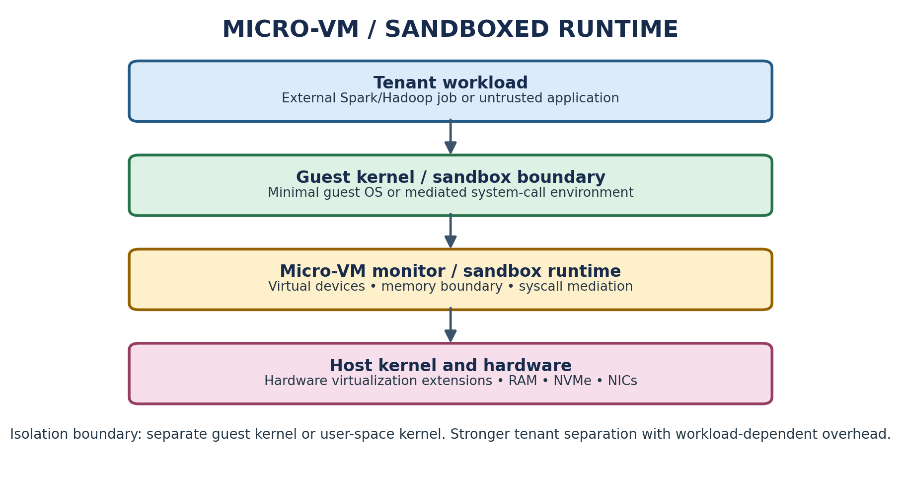
Figure 3: Micro-VM / sandboxed runtime architecture
A micro-VM gives a workload a lightweight virtual machine boundary with a minimal guest kernel and a small device model. A sandboxed container runtime such as gVisor instead intercepts or implements many application system calls in a user-space kernel boundary. The exact mechanism depends on the selected runtime. CPU and memory are constrained per workload; storage is provided through controlled virtual block devices or filesystem interfaces; and networking passes through a restricted virtual interface.
The isolation boundary is stronger than ordinary shared-kernel containers when a separate guest kernel or user-space kernel is used. It adds startup, memory and I/O overhead compared with standard containers, but is useful for research collaborators' less-trusted jobs and multi-tenant services that need more separation than namespaces alone.

1.2 Comparison of trust boundaries and resource virtualization
Aspect | Type-1 VM | OS-level container | Micro-VM / sandbox
Isolation enforcer | Hypervisor + hardware virtualization | Host kernel: namespaces, cgroups, seccomp | Micro-VM monitor / guest kernel or user-space kernel
CPU | vCPU scheduling, virtual timers, CPU shares/quotas | Host scheduler plus cgroup CPU quota and shares | vCPU scheduling or sandbox CPU limits
Memory | Guest physical memory mapped to host; EPT/NPT; ballooning | Shared host memory; cgroup limits; page cache accounting | Per-VM guest memory or sandbox memory limits
Storage | Virtual disks, virtual controllers, shared datastore | Layered images, writable layers and mounted volumes | Virtual block device or controlled filesystem
Network | Virtual NIC, virtual switch, VLAN/overlay policies | veth, bridge, overlay network and network policy | Virtual NIC or restricted network endpoint
Trust boundary | Between guest VMs at hypervisor | Containers share host kernel | Separate guest kernel or syscall sandbox boundary
EduCloud role | SIS database and legacy workloads | Stateless web/API and trusted internal services | External research workloads and sensitive tenant-facing jobs

A Type-2 hypervisor is not selected as a production architecture because it runs above a general-purpose host operating system and adds another software layer. It remains useful for developer laptops, classroom demonstrations and nested test environments. The three selected approaches satisfy the requirement for meaningfully distinct architectures.

1.3 Initial placement recommendation
- Place SIS database VMs on a restricted host pool with dedicated CPU and memory reservations, encrypted storage and tightly controlled administrator access.
- Run stateless SIS/LMS web and API components in containers on a separate application pool; apply cgroup quotas and network policies.
- Use micro-VMs or a hardened sandbox runtime for workloads whose code or tenant is less trusted.
- Keep management services, image registries and backup infrastructure in separate management/security zones.

TASK 2 – IDENTIFY THE DOMINANT OVERHEAD SOURCE (2 MARKS)
Approach | Dominant overhead source | Where it occurs and why it grows
Type-1 VM | VM exits/traps and guest memory translation (EPT/NPT walks) | During privileged operations, device access and guest/host transitions. More VMs and I/O-intensive workloads increase scheduling contention, exits and translation pressure.
Container | Virtual-switch processing and shared-kernel system-call / scheduler contention | At host-kernel networking and syscall paths. More co-located containers increase packet processing, context switches, lock contention and cgroup scheduling work.
Micro-VM / sandbox | VM exits and virtual-device I/O, or syscall interception in a user-space kernel | At the monitor/device boundary or sandbox syscall boundary. High syscall rates and I/O-heavy jobs increase transitions, emulation and mediation cost.

The dominant source is workload-dependent. For SIS database VMs, memory translation and storage I/O can dominate; for containerized web services, virtual networking and shared-kernel contention are often more visible; for sandboxed workloads, syscall interception or virtual-device mediation can become significant. The model in Task 3 therefore treats overhead as an explicit parameter instead of assuming one universal percentage.

TASK 3 – BUILD A QUANTITATIVE PERFORMANCE MODEL (6 MARKS)

3.1 Given parameters and additional assumptions
Parameter | Given value / assumption
Physical CPU cores per host | 64
vCPU:pCPU overcommit ratio | 1:1, 2:1, 4:1 and 8:1
RAM per host | 512 GB
Average VM memory demand | 8 GB
Cost of one VM exit | 1.5 microseconds
Native system-call cost | 0.2 microseconds
Network line rate | 25 Gbps per NIC; two NICs per host
Model CPU virtualization overhead | VM 5%; container 2%; micro-VM/sandbox 8% (explicit modelling assumptions, not measured facts)
Memory safety reserve | 10% of RAM retained for host, cache and operational headroom
Network efficiency factor | VM 0.90; container 0.95; micro-VM/sandbox 0.85 (planning assumptions)
Service-level target | At most 10% degradation from the equivalent bare-metal baseline

The overhead factors are deliberately stated assumptions used to demonstrate a transparent model. Actual values depend on CPU generation, hypervisor/runtime, kernel, device drivers, workload and configuration. They must be replaced by measurements in Task 9.

3.2 CPU capacity and steal-time model
Let C = 64 physical cores, r = vCPU:pCPU overcommit ratio, and h = virtualization overhead fraction. The theoretical vCPU count is V = C × r. If a host's CPU time is evenly shared under sustained full contention, the average physical-core-equivalent capacity per vCPU is:
CPU capacity per vCPU = (1 − h) / r physical-core equivalents.
The percentage of a single physical core available to each vCPU is therefore 100 × (1 − h) / r. A simple estimate of the scheduling/steal fraction under full contention is:
Steal fraction ≈ max(0, 1 − 1/r), before adding virtualization overhead. Effective per-vCPU capacity relative to one core = (1 − h)/r.
Overcommit r | VM h=5% | Container h=2% | Micro-VM h=8% | Approx. steal fraction
1:1 | 95.0% | 98.0% | 92.0% | 0%
2:1 | 47.5% | 49.0% | 46.0% | 50%
4:1 | 23.75% | 24.5% | 23.0% | 75%
8:1 | 11.88% | 12.25% | 11.5% | 87.5%

Example: at 4:1 VM overcommit, the 64-core host exposes 256 vCPUs. Under sustained full contention and the assumed 5% virtualization cost, each vCPU receives approximately 0.95/4 = 0.2375 of a physical core, or 23.75%. This is not a prediction of every workload's observed CPU speed; it is a capacity-sharing estimate. SIS latency-sensitive database and authentication services should not be placed at high overcommit.

3.3 Memory capacity before ballooning or swapping
Usable memory after a 10% operational reserve is 512 × 0.90 = 460.8 GB. With average demand of 8 GB per VM, the memory-limited count is floor(460.8/8) = 57 VMs per host. Without the reserve, the arithmetic ceiling would be 512/8 = 64 VMs, but operating at the ceiling leaves no room for the host, cache bursts or metadata.
For 16 hosts, the planning ceiling is 16 × 57 = 912 average-demand VM equivalents, assuming memory is evenly distributed and no host-level reservations reduce the usable amount. The current 400 VMs average 25 per host if evenly placed, but uneven placement and peak demand can still cause memory pressure. Ballooning, swapping or page sharing becomes necessary when aggregate resident demand exceeds usable memory or when reservations and host overhead are not accounted for.

3.4 I/O and network throughput model
The host has two 25 Gbps NICs, giving a theoretical aggregate line rate of 50 Gbps in each direction when link aggregation and workload distribution allow both links to be used. Let N be the number of equally active instances and η be the assumed efficiency factor. An idealized per-instance network share is:
T_instance = (50 × η) / N Gbps.
Active instances N | Type-1 VM η=0.90 | Container η=0.95 | Micro-VM η=0.85
1 | 45.00 Gbps | 47.50 Gbps | 42.50 Gbps
4 | 11.25 Gbps | 11.88 Gbps | 10.63 Gbps
8 | 5.63 Gbps | 5.94 Gbps | 5.31 Gbps
16 | 2.81 Gbps | 2.97 Gbps | 2.66 Gbps

This equal-share model is an upper-bound planning approximation. Real throughput is limited by the slowest of the physical NIC, virtual switch, storage backend, per-VM rate limit, CPU packet-processing capacity and external network. For storage I/O, use the same sharing principle: if the shared datastore sustains B IOPS and N workloads are equally active, ideal IOPS per workload is B/N. Measure B with fio; do not assume the NVMe device's advertised maximum is the shared-backend result.

3.5 Density under a 10% degradation target
For CPU-bound workloads, the simple capacity constraint is (1 − h)/r ≥ 0.90 if every instance must retain at least 90% of one dedicated core. This permits only r ≤ (1 − h)/0.90. For VM h=0.05, r ≤ 1.056; for containers h=0.02, r ≤ 1.089; for micro-VM h=0.08, r ≤ 1.022. Therefore, under a strict per-instance CPU target, near-1:1 allocation is required. Higher density is possible only when workloads are not simultaneously CPU-saturated and the SLA is based on observed service response rather than a dedicated-core equivalence.
A practical density bound is the minimum of CPU, memory and network limits: N_max = min(N_CPU, N_RAM, N_NET). With memory as above, N_RAM = 57 VM equivalents per host. For an illustrative 8-vCPU VM at 1:1, CPU capacity is 64/8 = 8 such VMs if each is guaranteed 8 physical cores; at 2:1, 16 VMs can be configured but cannot all receive dedicated-core performance simultaneously. The final placement limit must be established from repeated benchmark runs and the 10% degradation criterion.

3.6 Model limitations
- The model assumes average sharing and does not capture burstiness, NUMA locality, cache misses, storage queue depth or workload correlation.
- The two NICs are not automatically equivalent to a single 50 Gbps link; bonding mode, switch design and traffic direction matter.
- Memory demand of 8 GB is an average VM demand supplied by the assignment; research jobs may require much more.
- Overcommit ratios describe configured vCPU capacity, not guaranteed CPU performance.

TASK 4 – ANALYSE PERFORMANCE UNDER DIFFERENT OPERATING CONDITIONS (4 MARKS)
Condition | Type-1 VM | Container | Micro-VM / sandbox
Best case | Low overcommit, CPU pinning/NUMA-aware placement, virtio/paravirtual drivers and low I/O contention. Few VM exits; stable latency. | Small stateless services, warm images, cgroup limits correctly sized and low virtual-switch traffic. Minimal kernel boundary overhead. | Small guest images, low syscall and virtual-device activity, warm instances and adequate CPU/memory reservation.
Typical registration week | Mixed web/database demand causes scheduler contention and shared-storage queues. Failed logins may follow authentication latency or database saturation. | Many concurrent HTTP requests raise virtual-switch packet rate, context switches and shared-kernel pressure. Scaling replicas helps only if database and network are not bottlenecks. | Extra isolation costs more CPU and memory; syscall mediation and virtual-device paths can increase tail latency, but resource limits contain noisy tenants.
Worst case | High vCPU overcommit, memory ballooning/swapping, I/O storm and live migration during peak. VM exits, page walks and storage queues increase; p95 latency rises and throughput falls. | Noisy neighbour exhausts CPU or memory; shared kernel and overlay networking contend. A kernel-level issue can affect all containers; packet drops and throttling raise latency. | High syscall rate, intensive virtual I/O and simultaneous migration/startup can overload the monitor or sandbox. Stronger isolation does not remove physical resource contention.

For EduCloud's registration-week issue, the first diagnostic step should be correlation rather than immediately increasing VM count: compare authentication-service latency, database wait time, CPU ready/steal, memory pressure, storage queue depth, virtual-switch drops and p95 network latency. Failed logins can be a symptom of timeouts or overloaded identity services, not necessarily an incorrect password or a hypervisor defect.

TASK 5 – SECURITY THREAT AND VULNERABILITY ANALYSIS (3 MARKS)
Threat category | Type-1 VM exposure | Container exposure | Micro-VM / sandbox exposure | Likely CIA impact
VM/container escape | Hypervisor or device-emulation flaw can cross guest boundary; attack surface is smaller than a full host OS but highly privileged. | Shared-kernel vulnerability may allow container escape to host; more direct kernel sharing. | Separate guest kernel or syscall sandbox reduces direct shared-kernel exposure; monitor/runtime bugs remain. | Confidentiality and integrity of student records; availability of host.
Cross-tenant side channel | Co-resident VMs may infer information through cache, branch predictor or SMT resources. | Containers share kernel and hardware; process-level side channels remain possible. | Separate guest boundary helps but shared CPU caches and SMT can still leak timing information. | Confidentiality.
Unpatched guest/kernel and VM sprawl | Outdated guest kernels and unmanaged VM images expand attack surface. | Outdated host kernel/runtime affects many containers; stale images may reintroduce vulnerabilities. | Guest images and sandbox runtimes require patching; minimal images reduce but do not eliminate risk. | Integrity and availability; possible data exposure.
Image tampering / snapshot leakage | Copied VM images may contain credentials, student data or keys; unsigned images can be modified. | Untrusted container images may contain malware or vulnerable packages; secrets can be embedded in layers. | Micro-VM images and sandbox bundles also need provenance and integrity checks. | Confidentiality and integrity.
Virtual-network sniffing/spoofing | Misconfigured virtual switches, promiscuous ports or weak segmentation can expose traffic. | Flat bridges/overlays can allow lateral movement if network policies are absent. | Restricted virtual NICs and per-tenant policies reduce reachability but configuration errors remain. | Confidentiality, integrity and availability.
Insecure live migration / management plane | Migration traffic and hypervisor APIs are privileged; weak authentication or unencrypted channels can expose memory state. | Orchestration APIs, registry credentials and host control sockets are high-value targets. | Micro-VM monitor and orchestration control plane require strong authorization and audit. | All three CIA properties.

The audit findings map directly to two urgent controls: outdated guest kernels require a tracked patch and vulnerability-management process, while freely copied VM images require a controlled image registry, signing, access control and audit logs. Departmental workloads must not rely only on shared-host placement; sensitive SIS workloads need enforced compute, storage and network boundaries.

TASK 6 – FORMULATE THE ISOLATION–PERFORMANCE TRADE-OFF (3 MARKS)
The design objective is to maximise useful workload density while satisfying the SIS isolation requirement and a maximum 10% performance degradation target. Define decision variables:
- x_a ∈ {0,1}: select architecture a (Type-1 VM, container, micro-VM/sandbox) for a workload class.
- n_j: number of instances of workload class j placed on a host.
- d_j ∈ {0,1}: allocate a dedicated host pool to sensitive workload j.
- r_j: vCPU:pCPU overcommit ratio; m_j: memory allocation; b_j: network bandwidth reservation.
A simplified cost function is:
Minimise Cost = c_H × H + c_O × O + c_S × S + c_M × M
where H is the number of hosts, O is operational/management effort, S is security-control cost and M is migration/maintenance cost. A density-oriented alternative maximises Σ n_j subject to the following constraints:
- Performance: degradation_j ≤ 10% for SIS and other latency-sensitive services.
- Memory: Σ memory_demand_j ≤ 0.90 × 512 GB per host.
- Network: Σ reserved_bandwidth_j ≤ measured usable host bandwidth.
- Isolation: SIS database must use a VM or dedicated trust boundary; external tenants cannot share its host pool.
- Capacity: total assigned CPU, memory and I/O must remain within tested host limits.
- Availability: N+1 capacity and migration headroom must be maintained during patching.
A practical decision is not to maximise raw instance count. It is to minimise total cost while preserving the SIS SLA. Containers may be used for trusted stateless services where density matters; VMs or micro-VMs are selected where the security constraint dominates.

TASK 7 – EVALUATE MITIGATION STRATEGIES (4 MARKS)
Mitigation | Threat addressed and benefit | Residual risk | Estimated performance / density cost | SIS acceptability
Dedicated host pool for SIS database; reserve CPU/RAM and avoid high overcommit | Reduces cross-tenant co-residency, noisy-neighbour interference and some side-channel exposure. | Does not remove hypervisor vulnerabilities, administrator risk or network misconfiguration. | Lower density because capacity is reserved. With 1:1 placement, CPU sharing loss is avoided; spare capacity is intentionally retained. | Acceptable and recommended for critical SIS database.
Signed golden images, private registry, image scanning and controlled snapshot permissions | Prevents or detects image tampering, stale packages and uncontrolled copying of data-bearing images. | A signed image can still contain a vulnerable package; registry credentials can be stolen. | Image scanning and signing add build/publish time, not normally runtime CPU overhead. Scanning may temporarily consume registry resources. | Acceptable; strong governance benefit with negligible application runtime cost.
Micro-VM / sandbox runtime for external or untrusted workloads | Adds a stronger boundary than ordinary shared-kernel containers; reduces direct host-kernel exposure. | Monitor/runtime bugs and hardware side channels remain; configuration must be maintained. | Use model assumption h=8% versus container h=2%; effective capacity at 1:1 is 92% versus 98% of a core, a 6 percentage-point modelled difference. | Acceptable for external tenants; do not use for every latency-critical SIS component without testing.
Micro-segmentation, per-tenant networks, encrypted storage and encrypted migration | Reduces lateral movement, sniffing and exposure of data in transit/at rest. | Misconfigured policy, compromised identity or endpoint remains possible. | Small packet-processing and encryption CPU cost; benchmark under realistic throughput. No fixed percentage is assumed without measurement. | Required for SIS and external collaborators.

The modelled overhead comparison for micro-VMs and containers is illustrative only. The actual cost of each mitigation must be measured with identical workloads and resource allocations. Disabling SMT can reduce some cross-thread side-channel exposure but may lower available logical CPU capacity; it should be evaluated on the actual host rather than assigned an invented universal percentage.

TASK 8 – IMPLEMENT AND TEST (4 MARKS)

8.1 Reproducible test environment
A suitable lab can be built on a Linux host with hardware virtualization enabled. Use KVM/QEMU for the Type-1-style VM test, Docker or Podman for standard containers, and Kata Containers or gVisor for the sandbox/micro-VM comparison. A laptop with nested virtualization is acceptable if its CPU, RAM, kernel and nested-virtualization limitations are documented. Do not claim that a Type-2 VirtualBox test is equivalent to production Type-1 performance.
Component | Suggested configuration
Host OS | Supported Linux distribution; record exact release and kernel
VM approach | KVM/QEMU with virtio disk and virtio-net; record vCPU and RAM allocation
Container approach | Docker/Podman; record image digest, cgroup version, CPU and memory limits
Sandbox approach | Kata Containers or gVisor; record runtime version and isolation mode
Workloads | sysbench or stress-ng (CPU); fio (disk); iperf3 (network); memory stress workload
Scale | 1, 2, 4, 8 and 16 instances; reduce proportionally if hardware-limited
Repetitions | At least 5 runs per configuration after a warm-up; report mean and standard deviation

8.2 Example commands
Record exact command output, versions and configuration. The following are starting examples; adjust resource limits to the host and keep allocations identical across approaches.
KVM availability and host details:
lscpu
free -h
uname -a
lsmod | grep kvm
virsh list --all
Container workload examples:
docker run --rm --cpus=2 --memory=4g alpine:latest sh -c 'apk add --no-cache sysbench && sysbench cpu run'
docker stats
docker run --rm --network host networkstatic/iperf3 -c <iperf-server> -t 30
fio --name=randread --filename=/tmp/fio-test --size=1G --rw=randread --bs=4k --iodepth=16 --runtime=30 --time_based
For VM tests, create VMs with the same vCPU, RAM, disk and network limits as the container tests. Run the same workload binaries and duration inside each guest. For sandbox tests, configure the chosen runtime explicitly and save its version and configuration.

8.3 Test cases and security validation
Test | Procedure | Record
CPU-bound | Run identical sysbench CPU or stress-ng workload at 1/2/4/8/16 instances. | Events per second, CPU utilisation, steal/ready time and p95 runtime.
Disk I/O | Run fio with the same block size, queue depth, file size and duration. | IOPS, MB/s, average latency and p95 latency.
Network | Run iperf3 client/server with identical streams and duration. | Throughput, retransmits, CPU use and packet drops.
Memory-intensive | Run a controlled memory allocation/stream workload without exceeding host safety limits. | Working set, major faults, swap, OOM events and runtime.
Noisy neighbour | Run a CPU or disk stressor on one instance while measuring a fixed latency-sensitive workload on another. | Change in throughput and p95 latency relative to quiet baseline.
Security property | Inspect namespaces/cgroups, container kernel sharing, sandbox runtime, image signatures and tenant network policy. | Commands, configuration and screenshots proving the control is active.

Safety note: do not run stress tests on production EduCloud or a shared university system without written authorization. Use an isolated lab and stop tests if the host becomes unstable.

8.4 Evidence to insert
- Screenshot of host hardware/OS information and virtualization extensions.
- Screenshot of each approach running the same workload.
- Terminal output for CPU, fio, iperf3 and memory tests.
- Screenshot or command output proving the security boundary or mitigation is enabled.
- Configuration files and exact commands sufficient for another student to reproduce the test.

TASK 9 – RECORD EXPERIMENTAL PERFORMANCE (3 MARKS)
No experimental results are fabricated in this report. The following tables are designed to be filled with actual output from Task 8. For every configuration, run at least five repetitions after warm-up and calculate mean and standard deviation. Use the same host, resource allocation, workload, duration and repetitions for all approaches.

9.1 Measurement table
Approach | Instances | Throughput (mean) | Latency mean (ms) | Latency p95 (ms) | CPU steal / ready (%) | Memory / instance (GB)
Type-1 VM | 1
Type-1 VM | 2
Type-1 VM | 4
Type-1 VM | 8
Type-1 VM | 16
Container | 1
Container | 2
Container | 4
Container | 8
Container | 16
Micro-VM/sandbox | 1
Micro-VM/sandbox | 2
Micro-VM/sandbox | 4
Micro-VM/sandbox | 8
Micro-VM/sandbox | 16

9.2 Noisy-neighbour and mitigation results
Approach / condition | Baseline p95 latency (ms) | Interference p95 (ms) | Change (%) | Throughput change (%)
Type-1 VM – quiet / noisy
Container – quiet / noisy
Micro-VM – quiet / noisy
Selected mitigation – off / on

Percentage change calculation: ((interference value − baseline value) / baseline value) × 100. For throughput reduction, report ((baseline throughput − interference throughput) / baseline throughput) × 100.

9.3 Graphs to produce from measured values
- Graph 1: throughput versus number of instances (separate series for the three approaches).
- Graph 2: p95 latency under quiet and noisy-neighbour conditions.
- Optional graph 3: performance degradation versus instance count, with the 10% service-level threshold marked.
The graphs must be generated from the filled measurement table, not from the analytical assumptions in Task 3. Include error bars based on standard deviation when the plotting tool supports them.

TASK 10 – COMPARE THEORY WITH EXPERIMENT (4 MARKS)

10.1 Comparison method
For each approach and instance count, compare the Task 3 predicted throughput/capacity with the Task 9 measured result. Calculate relative error as:
Relative error (%) = |Measured − Predicted| / Predicted × 100.
A positive or negative gap should be interpreted in context. Caching, CPU frequency scaling, NUMA placement, hypervisor scheduling, nested virtualization, storage caching, network offload and benchmark noise can cause measured values to differ from a simplified model.

10.2 Interpretation framework
Question | How to interpret the result
Do degradation trends agree with the model? | Check whether throughput generally falls and latency rises as active instances increase. If not, investigate workload parallelism, caching and unused host capacity.
Which approach scales better? | Compare the slope of throughput and p95 latency as instance count rises. Do not choose from one run or throughput alone.
Why do measured values differ? | Calculate relative error and inspect CPU steal, context switches, memory faults, I/O queue depth, packet drops and nested-virtualization overhead.
Does measurement change the security conclusion? | A faster container result does not erase its shared-kernel boundary. A micro-VM performance penalty may be acceptable for untrusted tenants if isolation is required.

10.3 Result interpretation record
After completing the tests, write a short evidence-based paragraph here: identify the approach with the best measured throughput, the approach with the lowest p95 latency, the point at which degradation exceeded 10%, and whether the security mitigation changed performance materially. Explain any disagreement between model and experiment using measured counters rather than speculation.

TASK 11 – RECOMMEND AND DEFEND THE FINAL ARCHITECTURE (4 MARKS)

11.1 Recommended architecture for the current EduCloud workload
A hybrid placement strategy is recommended. Keep SIS database and other highly sensitive stateful components on Type-1 VMs in a restricted host pool. Use standard containers for trusted, stateless web/API services and internal microservices where rapid deployment and density are useful. Use micro-VMs or a sandboxed runtime for workloads requiring a stronger boundary than an ordinary container, especially workloads from less-trusted tenants.

11.2 Why this is preferable to a single approach
Criterion | Type-1 VM | Container | Micro-VM / sandbox | Recommended use
Isolation | Independent guest OS and hypervisor boundary | Shared host kernel | Separate guest or syscall sandbox boundary | VM for SIS data; sandbox for untrusted tenants
Performance / density | More overhead and larger footprint than containers | High density and fast startup | Intermediate or workload-dependent | Containers for trusted stateless services
Operations | Guest OS patching and image lifecycle | Host kernel and image/runtime lifecycle | Runtime plus guest/sandbox image lifecycle | Automate patching and image governance
Scaling | VM provisioning is heavier | Fast replica scaling | Faster than full VMs in many configurations, but runtime-dependent | Autoscale API containers; reserve VM capacity for SIS
Risk | Hypervisor and guest vulnerabilities | Shared-kernel escape risk | Monitor/runtime and hardware side-channel risk | Use defence in depth; no single boundary is sufficient

11.3 Operational controls
- Maintain a golden-image pipeline with vulnerability scanning, signing, versioning and rollback.
- Patch guest kernels and host hypervisors on a defined schedule; prioritize critical vulnerabilities.
- Separate management, storage, SIS, departmental and external-tenant networks.
- Use role-based access control, multi-factor authentication, privileged-access logging and audited change management.
- Monitor CPU ready/steal time, memory ballooning/swapping, storage latency, virtual-switch drops, p95 response time and authentication failures.
- Plan N+1 host capacity and test live migration before patch windows.

11.4 Growth from 400 to several thousand instances
The recommended design remains practical only if capacity is managed by workload class rather than by a single global density target. Add host pools horizontally, automate image and configuration management, use quota-based tenant onboarding, and enforce admission control based on CPU, RAM, IOPS and network demand. Several thousand small containers may fit more efficiently than the same number of full VMs, but stateful and untrusted workloads should retain stronger boundaries. Recalculate capacity from measured resource profiles at each growth stage.

TASK 12 – DAY-4 DESIGN CHALLENGE: RE-EVALUATE AND ADAPT THE DESIGN (8 MARKS)

A. Impact analysis (2 marks)
The original design assumed university-controlled departmental workloads with a relatively familiar workload mix. External research collaborators introduce less-trusted tenants and long-running Spark/Hadoop jobs. These jobs are I/O- and network-intensive, may saturate shared storage and NIC queues, and can run concurrently with the three-times-normal registration peak. Live migration during patching adds transient CPU, memory-copy and network traffic. The new regulation requires demonstrable isolation of student records, not merely a statement that tenants are logically separated.
- The trust assumption changes: external collaborators must be treated as untrusted tenants.
- The workload mix changes: batch analytics can consume sustained CPU, memory bandwidth, storage IOPS and network bandwidth.
- The timing assumption changes: patching and live migration may overlap with peak service demand.
- The compliance requirement changes: evidence of isolation, access controls, logging and policy enforcement must be retained.
- APIs and storage access must enforce tenant identity and authorization; network separation alone is insufficient.

B. Evaluation of the original design (2 marks)
A design that places all VMs and containers in one shared host pool is no longer adequate. Even when hypervisor isolation is present, co-residency creates performance interference and side-channel concerns. Ordinary containers are unsuitable as the sole boundary between SIS and external Spark/Hadoop jobs because they share the host kernel. A single shared storage and network path can also allow long-running jobs to degrade SIS response time.
The CPU model shows that overcommit reduces per-instance capacity as 1/r. During a 3× registration peak, an already busy host may exceed its planned CPU share. The network model likewise shows per-instance bandwidth falling as the number of active consumers rises. Live migration adds additional traffic and consumes host CPU; therefore migrations should be rate-limited and scheduled outside registration peaks where possible.

C. Adaptation or redesign (2 marks)
Decision: MODIFY the original hybrid architecture rather than retain a single shared pool. Create physically or logically separate host pools with enforced placement and network boundaries:
- SIS secure pool: dedicated Type-1 hosts for SIS database and identity components; reserve CPU and memory, avoid aggressive overcommit, encrypt storage and backups, and prohibit external tenant placement.
- University application pool: trusted LMS, examination and API services; use containers for stateless components with cgroup quotas, micro-segmentation and autoscaling.
- External research pool: dedicated hosts or a separately controlled resource pool for Spark/Hadoop. Run collaborator workloads inside micro-VMs or hardened VM guests; apply per-tenant quotas, restricted virtual NICs and separate storage namespaces.
- Network and storage isolation: use separate VLANs/overlays, firewall policy, tenant-specific identities and encryption. Consider SR-IOV or dedicated NIC queues only after validating isolation and operational requirements.
- Migration and patching: encrypt migration traffic, authenticate both endpoints, log operations, reserve migration bandwidth and use maintenance windows outside registration peaks.
Figure 4: Type-1 VM isolation boundary used for the protected SIS pool
The figure represents the VM boundary used for SIS, while the complete revised design adds separate host pools, a container application pool and a micro-VM research pool. The physical separation of the SIS host pool is the strongest practical control when demonstrable separation is required.

D. Evidence-based defence (2 marks)

Capacity and availability reasoning
The registration peak is approximately 3× normal. Capacity planning must therefore use measured peak CPU, memory, IOPS and network demand rather than average utilization alone. Maintain spare host capacity in each critical pool so one host can be patched or fail without forcing SIS onto the research pool. A simple N+1 rule is to ensure that the remaining hosts can carry the protected workload after the largest host is removed; verify this with a live-migration and host-failure exercise.

Cost, density and trade-offs
Dedicated SIS hosts reduce density and may increase hardware cost, but they reduce noisy-neighbour exposure and make tenant isolation easier to demonstrate. Containers retain high density for trusted application services. Micro-VMs add memory and startup overhead for research tenants but limit the blast radius of a compromised workload. Separate host pools, image governance and encrypted migration increase operational complexity; they are justified by the sensitivity of student records and the external-tenant requirement.

Final defence
The modified design is preferable because it assigns isolation strength according to data sensitivity and tenant trust. SIS receives the strongest placement and resource guarantees; trusted university web services retain container efficiency; and external analytics workloads receive a separate host pool with a stronger VM/sandbox boundary. This design directly addresses the new I/O contention, three-times peak load, live-migration and regulatory isolation requirements. Final capacity and performance claims must be confirmed by the experiments in Tasks 8–10.

CONCLUSION
EduCloud's performance and security problems arise from a combination of resource contention, shared infrastructure, weak image governance and inconsistent guest patching. Type-1 VMs provide a strong boundary for sensitive stateful services, containers provide efficient deployment for trusted stateless services, and micro-VMs or sandboxed runtimes provide an additional boundary for less-trusted workloads. A quantitative model helps expose the effects of CPU overcommit, memory limits and shared network capacity, while reproducible tests are needed to replace assumptions with measured evidence. Under the Day-4 challenge, separate host pools, strict tenant isolation, encrypted migration and controlled capacity reservation are necessary to protect SIS while supporting external big-data workloads.

REFERENCES / TECHNICAL DOCUMENTATION
- Course assignment brief: CLOUD COMPUTING AND BIG DATA – Assignment 2, CO2 (provided document).
- Linux Kernel Documentation – Control Group v2: https://docs.kernel.org/admin-guide/cgroup-v2.html
- Linux Kernel Documentation – Namespaces: https://man7.org/linux/man-pages/man7/namespaces.7.html
- QEMU Documentation: https://www.qemu.org/docs/
- KVM Documentation: https://www.linux-kvm.org/
- Docker Documentation – Resource constraints: https://docs.docker.com/engine/containers/resource_constraints/
- Kata Containers Documentation: https://katacontainers.io/
- gVisor Documentation: https://gvisor.dev/docs/
- fio Documentation: https://fio.readthedocs.io/
- iperf3 Documentation: https://iperf.fr/iperf-doc.php

SUBMISSION CHECKLIST
Requirement | Status
All 12 tasks addressed | ☒ Yes ☐ Partly ☐ No
Three distinct architectures and diagrams included | ☒ Yes ☐ Partly ☐ No
CPU, memory, I/O and network model included | ☒ Yes ☐ Partly ☐ No
Threat model and mitigation analysis included | ☒ Yes ☐ Partly ☐ No
Implementation commands and test plan included | ☒ Yes ☐ Partly ☐ No
Actual experimental data and graphs inserted | ☐ Yes ☒ Partly ☐ No
Screenshots and execution logs attached | ☐ Yes ☒ Partly ☐ No
Day-4 redesign and defence completed | ☒ Yes ☐ Partly ☐ No
All text and diagrams use black and white only | ☒ Yes ☐ Partly ☐ No

D. Jeshurun Silas ____________________ ____________________
Student Signature Faculty Signature Program Director

APPENDIX A – DETAILED EXPLANATION OF VIRTUALIZATION
Virtualization is the abstraction of physical computing resources so that several isolated execution environments can share one physical computer. A physical host contains processors, memory, storage controllers and network interfaces. A virtualization layer presents controlled virtual versions of those resources to guest workloads. The operating system or application inside a virtual machine behaves as though it owns a computer, even though the physical resources are shared.
A virtual machine includes virtual hardware and a guest operating system. The hypervisor schedules virtual CPUs, maps guest memory to host memory, connects virtual disks to physical storage and forwards network traffic through virtual switches. The guest operating system remains independent of other guests. This independence is valuable when departments run different operating systems or require stronger isolation.
A container is different. It packages an application and its dependencies but shares the host kernel. Namespaces provide separate views of processes, mounts, users and networks. Control groups account for and limit resource consumption. This makes containers smaller and faster to start, but a weakness in the shared kernel can affect many containers.
A micro-VM uses a lightweight virtual machine boundary. It seeks to preserve a guest-kernel boundary while reducing the footprint of a conventional VM. A sandboxed runtime may instead mediate system calls through a user-space kernel. These approaches are useful when the tenant is less trusted than the platform operator.
For EduCloud, virtualization is not only a method of increasing server utilization. It is also a placement and security decision. SIS data needs strong separation, while stateless web services benefit from container density. The architecture should select the boundary according to the sensitivity of the data and the trustworthiness of the workload.

Worked example and practical interpretation
Worked interpretation: Suppose a host exposes 256 vCPUs at a 4:1 ratio. This is a configuration count, not a promise that 256 physical cores exist. If all 256 vCPUs become runnable together, they must share the 64 physical cores. The resulting waiting time can increase application response time even when the configured vCPU count appears generous. For the SIS login and registration path, a short period of CPU contention can create request timeouts and retries, which can increase load further.

Design implications for EduCloud
Operational decision: Use reservations and conservative overcommit for the database, identity service and other latency-sensitive components. Batch analytics can use lower-priority shares or queued execution when the host is busy. Review CPU ready/steal time together with application p95 latency; high CPU utilization alone does not prove that the scheduler is the bottleneck.

Validation, monitoring and evidence
Validation: Run the same CPU workload at each planned overcommit ratio. Record throughput, p95 completion time, host CPU utilization and ready/steal time. Repeat at least five times. A placement ratio should be accepted only if the measured service objective is maintained during the expected peak, not merely during an idle demonstration.

Practical checklist for the university cloud team
Before approving this component, the cloud team should record its owner, purpose, data classification, tenant boundary, resource request, permitted dependencies and recovery requirement. The configuration should be stored in version control and reviewed before deployment. Administrators should test both normal operation and failure conditions, including a denied cross-tenant request, resource exhaustion, host maintenance and restoration from backup. Results should include timestamps, software versions, configuration values and the exact test procedure. Any limitation must be stated clearly so that an analytical assumption is not mistaken for an observed production result.

COLOUR ARCHITECTURE DIAGRAM – A – DETAILED EXPLANATION OF VIRTUALIZATION
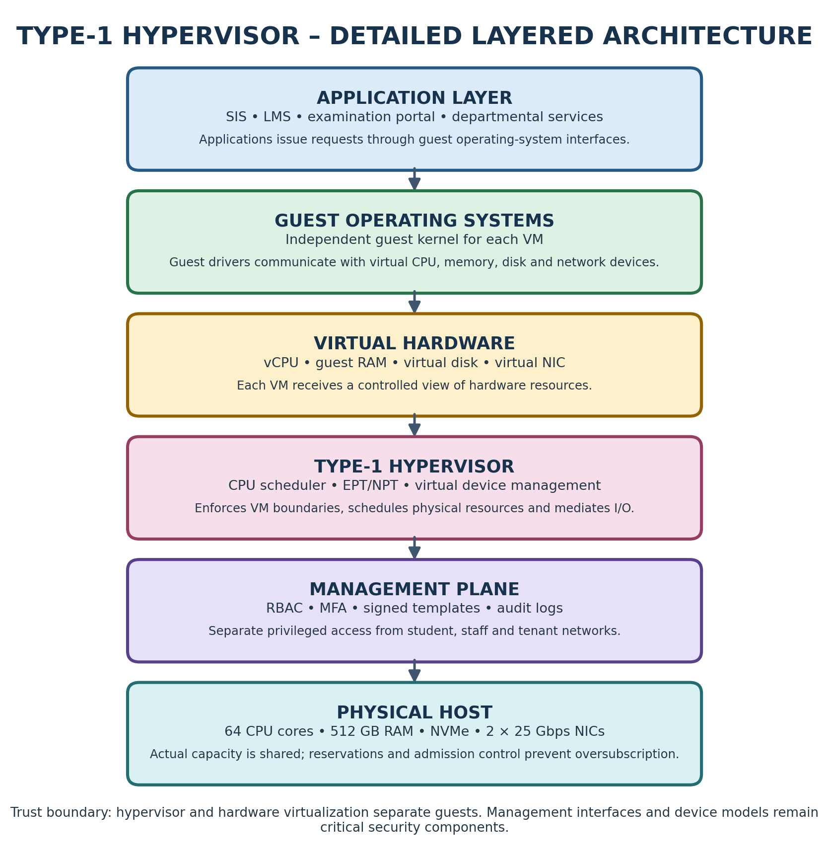
Figure: Detailed colour-coded architecture illustration.

APPENDIX B – TYPE-1 HYPERVISOR OPERATION
A Type-1 hypervisor executes directly on the physical server rather than as an ordinary application on a desktop operating system. During startup, firmware initializes the hardware and transfers control to the hypervisor. The hypervisor discovers processors, memory and devices, then starts management services and guest virtual machines.
When a VM is created, the administrator assigns virtual CPUs, memory, virtual disks and virtual network adapters. The hypervisor schedules vCPUs on physical cores. If two vCPUs need the same physical core at the same time, one may wait. The waiting time can appear as CPU ready or steal time depending on the platform and monitoring method.
Guest memory is translated through hardware-assisted second-level address translation such as Intel EPT or AMD NPT. The guest operating system maintains its own page tables, while the processor and hypervisor coordinate translation from guest-virtual addresses to host-physical addresses. This protects the memory of one guest from another, subject to correct hardware and hypervisor operation.
Virtual storage is commonly presented through virtual SCSI or paravirtualized devices. A guest sends I/O requests to its virtual controller; the hypervisor or host storage stack maps those requests to files, logical volumes or a shared datastore. Virtual networking follows a similar path: a guest virtual NIC connects to a virtual switch, which applies forwarding and isolation policy before traffic reaches the physical NIC.
The hypervisor is highly privileged. Its management interface must therefore be isolated from ordinary student networks, protected by multifactor authentication and monitored. Updates should be tested and applied through a controlled maintenance process.

Worked example and practical interpretation
Worked interpretation: Suppose a host exposes 256 vCPUs at a 4:1 ratio. This is a configuration count, not a promise that 256 physical cores exist. If all 256 vCPUs become runnable together, they must share the 64 physical cores. The resulting waiting time can increase application response time even when the configured vCPU count appears generous. For the SIS login and registration path, a short period of CPU contention can create request timeouts and retries, which can increase load further.

Design implications for EduCloud
Operational decision: Use reservations and conservative overcommit for the database, identity service and other latency-sensitive components. Batch analytics can use lower-priority shares or queued execution when the host is busy. Review CPU ready/steal time together with application p95 latency; high CPU utilization alone does not prove that the scheduler is the bottleneck.

Validation, monitoring and evidence
Validation: Run the same CPU workload at each planned overcommit ratio. Record throughput, p95 completion time, host CPU utilization and ready/steal time. Repeat at least five times. A placement ratio should be accepted only if the measured service objective is maintained during the expected peak, not merely during an idle demonstration.

Practical checklist for the university cloud team
Before approving this component, the cloud team should record its owner, purpose, data classification, tenant boundary, resource request, permitted dependencies and recovery requirement. The configuration should be stored in version control and reviewed before deployment. Administrators should test both normal operation and failure conditions, including a denied cross-tenant request, resource exhaustion, host maintenance and restoration from backup. Results should include timestamps, software versions, configuration values and the exact test procedure. Any limitation must be stated clearly so that an analytical assumption is not mistaken for an observed production result.

APPENDIX C – CONTAINER ISOLATION MECHANISMS
Containers provide process isolation without giving every application a separate guest kernel. The container runtime creates namespaces and cgroups, configures a filesystem view and starts the application process. A process namespace limits which processes the container can see. A mount namespace provides a separate view of mounted filesystems. A network namespace gives the container its own interfaces, routes and firewall context. User namespaces can map container identities to less-privileged host identities.
Control groups limit resource use. A CPU quota can prevent one container from consuming all processor time. A memory limit can constrain resident memory and trigger controlled failure rather than allowing uncontrolled host exhaustion. I/O controls can limit access to storage bandwidth or I/O operations when supported by the kernel and storage stack.
Capabilities divide traditional root privileges into smaller permissions. Seccomp can restrict the system calls a process is allowed to invoke. Mandatory access-control systems such as SELinux or AppArmor can further restrict file and process access. These controls reduce attack surface, but they do not transform a container into a separate kernel.
Because containers share the host kernel, the host kernel must be patched promptly. Containers should not run as privileged by default, should not mount the host root filesystem, and should not receive unnecessary device access. Secrets should be injected through a controlled secret-management mechanism rather than stored inside image layers.
For EduCloud, standard containers are appropriate for trusted stateless application services. They are not sufficient as the only boundary for external collaborators who can submit arbitrary research code. Those jobs should run in a separate pool and a stronger VM or sandbox boundary.

Worked example and practical interpretation
Worked interpretation: Suppose a host exposes 256 vCPUs at a 4:1 ratio. This is a configuration count, not a promise that 256 physical cores exist. If all 256 vCPUs become runnable together, they must share the 64 physical cores. The resulting waiting time can increase application response time even when the configured vCPU count appears generous. For the SIS login and registration path, a short period of CPU contention can create request timeouts and retries, which can increase load further.

Design implications for EduCloud
Operational decision: Use reservations and conservative overcommit for the database, identity service and other latency-sensitive components. Batch analytics can use lower-priority shares or queued execution when the host is busy. Review CPU ready/steal time together with application p95 latency; high CPU utilization alone does not prove that the scheduler is the bottleneck.

Validation, monitoring and evidence
Validation: Run the same CPU workload at each planned overcommit ratio. Record throughput, p95 completion time, host CPU utilization and ready/steal time. Repeat at least five times. A placement ratio should be accepted only if the measured service objective is maintained during the expected peak, not merely during an idle demonstration.

Practical checklist for the university cloud team
Before approving this component, the cloud team should record its owner, purpose, data classification, tenant boundary, resource request, permitted dependencies and recovery requirement. The configuration should be stored in version control and reviewed before deployment. Administrators should test both normal operation and failure conditions, including a denied cross-tenant request, resource exhaustion, host maintenance and restoration from backup. Results should include timestamps, software versions, configuration values and the exact test procedure. Any limitation must be stated clearly so that an analytical assumption is not mistaken for an observed production result.

COLOUR ARCHITECTURE DIAGRAM – C – CONTAINER ISOLATION MECHANISMS
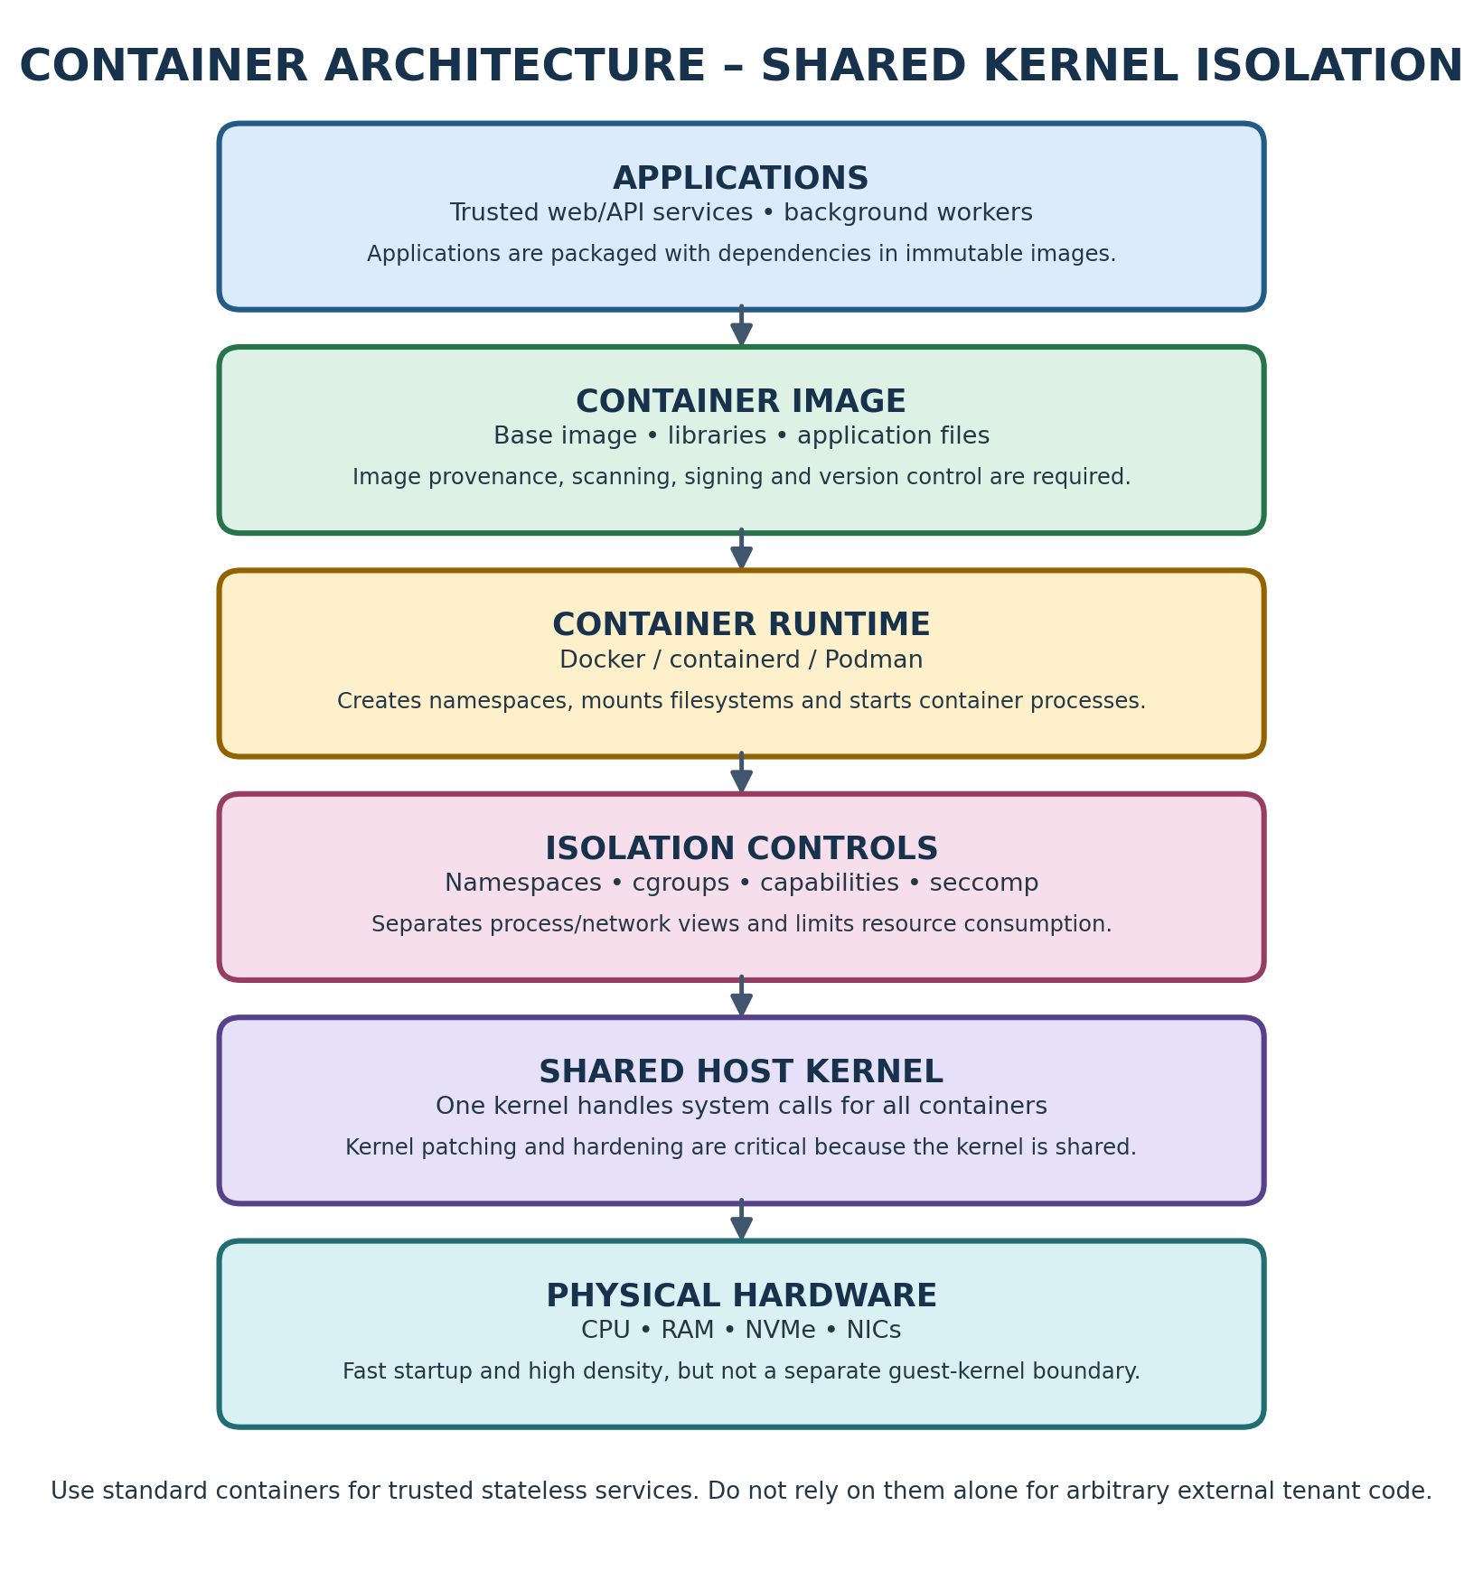
Figure: Detailed colour-coded architecture illustration.

APPENDIX D – MICRO-VM AND SANDBOXED RUNTIMES
A micro-VM is designed to reduce the amount of virtual hardware and management code required to launch an isolated guest. It normally runs a minimal guest kernel and a limited set of devices. Fewer devices can mean a smaller attack surface and less memory overhead than a general-purpose VM, although actual resource consumption depends on the implementation and guest image.
A sandboxed container runtime takes another route. Rather than exposing the host kernel directly to every application system call, it intercepts or mediates system calls using a user-space kernel or other sandbox mechanism. This can reduce the impact of a malicious or compromised application, but compatibility and performance depend on the calls used by the workload.
The isolation boundary is only as strong as its implementation and configuration. The runtime, monitor, host kernel, image supply chain and orchestration control plane all remain security-relevant. Updates must cover both the host and the guest or sandbox components.
The performance cost is workload-dependent. A micro-VM may incur virtual-device overhead and memory reserved for its guest kernel. A syscall-mediating sandbox may add overhead to workloads that make many system calls. CPU-intensive workloads that spend most of their time in user space may behave differently from workloads dominated by file, network or process operations.
EduCloud should use these mechanisms selectively. External Spark/Hadoop jobs are less trusted and can execute complex code; a VM or micro-VM boundary is suitable. The university should benchmark the chosen runtime using representative jobs before committing to a density target.

Worked example and practical interpretation
Worked interpretation: Suppose a host exposes 256 vCPUs at a 4:1 ratio. This is a configuration count, not a promise that 256 physical cores exist. If all 256 vCPUs become runnable together, they must share the 64 physical cores. The resulting waiting time can increase application response time even when the configured vCPU count appears generous. For the SIS login and registration path, a short period of CPU contention can create request timeouts and retries, which can increase load further.

Design implications for EduCloud
Operational decision: Use reservations and conservative overcommit for the database, identity service and other latency-sensitive components. Batch analytics can use lower-priority shares or queued execution when the host is busy. Review CPU ready/steal time together with application p95 latency; high CPU utilization alone does not prove that the scheduler is the bottleneck.

Validation, monitoring and evidence
Validation: Run the same CPU workload at each planned overcommit ratio. Record throughput, p95 completion time, host CPU utilization and ready/steal time. Repeat at least five times. A placement ratio should be accepted only if the measured service objective is maintained during the expected peak, not merely during an idle demonstration.

Practical checklist for the university cloud team
Before approving this component, the cloud team should record its owner, purpose, data classification, tenant boundary, resource request, permitted dependencies and recovery requirement. The configuration should be stored in version control and reviewed before deployment. Administrators should test both normal operation and failure conditions, including a denied cross-tenant request, resource exhaustion, host maintenance and restoration from backup. Results should include timestamps, software versions, configuration values and the exact test procedure. Any limitation must be stated clearly so that an analytical assumption is not mistaken for an observed production result.

COLOUR ARCHITECTURE DIAGRAM – D – MICRO-VM AND SANDBOXED RUNTIMES
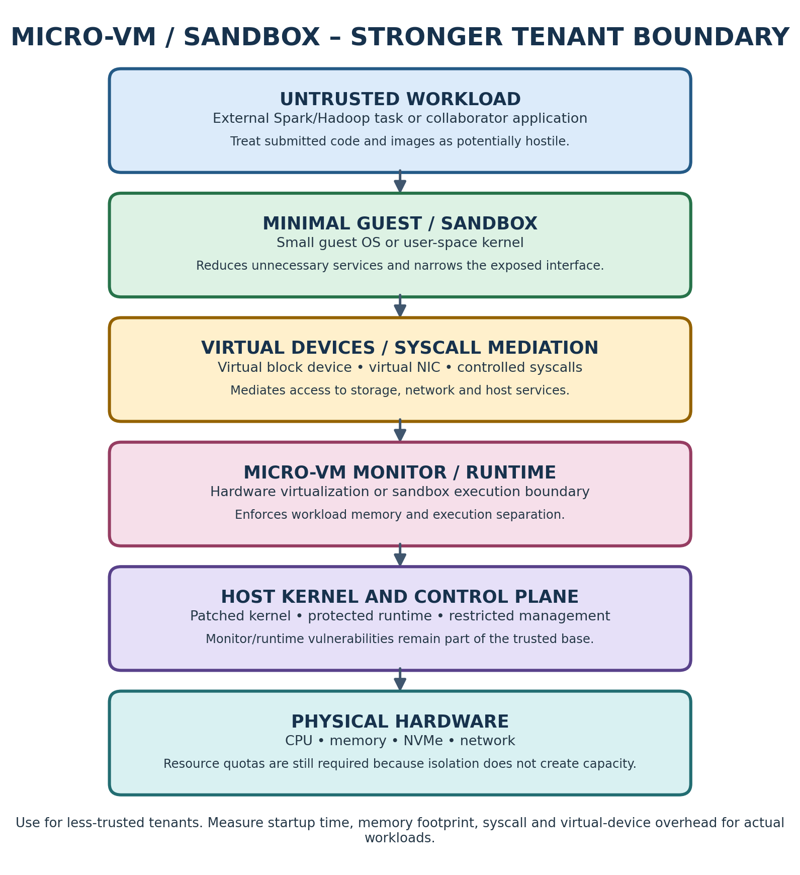
Figure: Detailed colour-coded architecture illustration.

APPENDIX E – TRUST BOUNDARIES AND THREAT SURFACES
A trust boundary separates components that are allowed to rely on one another from components that must be treated as potentially hostile. In a multi-tenant cloud, a department's VM, another department's VM, the host hypervisor, the management plane and the storage/network fabric are separate security domains.
For Type-1 virtualization, the hypervisor enforces the guest boundary. Device emulation, virtual firmware, management APIs and privileged administrators are part of the trusted computing base. A vulnerability in a device model or hypervisor can potentially undermine guest separation. Keeping virtual hardware minimal and patching the hypervisor reduces exposure.
For containers, the host kernel and container runtime are shared. A kernel vulnerability can cross boundaries that appear separate at the process level. This is why untrusted workloads should not be placed beside sensitive SIS processes in ordinary containers alone.
For micro-VMs, a guest-kernel boundary reduces direct sharing, but the monitor, virtual devices and host remain trusted components. Side channels through shared caches, memory bandwidth or SMT may still exist even when guest memory is isolated.
The management plane is especially sensitive. It can create VMs, attach disks, copy images, change network policy and inspect snapshots. Access should be restricted to named administrators, protected with MFA, logged and reviewed. A student or research collaborator should never have direct administrative access to the hypervisor management interface.
The platform should document each boundary, the mechanism that enforces it, the administrator responsible for it and the evidence used to verify it.

Worked example and practical interpretation
Worked interpretation: With the 10% reserve, the usable planning amount is 460.8 GB. At 8 GB average resident demand, 57 VMs use 456 GB and leave 4.8 GB of the planned usable pool. The 58th VM would require 464 GB and exceed that planning amount. This arithmetic is intentionally conservative; actual placement must also account for VM reservations, host overhead, workload peaks and NUMA layout.

Design implications for EduCloud
Operational decision: Separate configured memory from active working set. A VM configured with 16 GB may use 5 GB during a quiet period but need much more during a report or batch job. Research jobs should declare memory requests and limits. Database workloads should receive sufficient reserved memory to avoid repeated disk reads and should not depend on host swapping for normal operation.

Validation, monitoring and evidence
Validation: Record available memory, working set, major page faults, swap activity, balloon activity and out-of-memory events during the same workload. If memory pressure rises, reduce admission, move workloads to a suitable pool or increase capacity; do not treat ballooning and swapping as free extra RAM.

Practical checklist for the university cloud team
Before approving this component, the cloud team should record its owner, purpose, data classification, tenant boundary, resource request, permitted dependencies and recovery requirement. The configuration should be stored in version control and reviewed before deployment. Administrators should test both normal operation and failure conditions, including a denied cross-tenant request, resource exhaustion, host maintenance and restoration from backup. Results should include timestamps, software versions, configuration values and the exact test procedure. Any limitation must be stated clearly so that an analytical assumption is not mistaken for an observed production result.

COLOUR ARCHITECTURE DIAGRAM – E – TRUST BOUNDARIES AND THREAT SURFACES
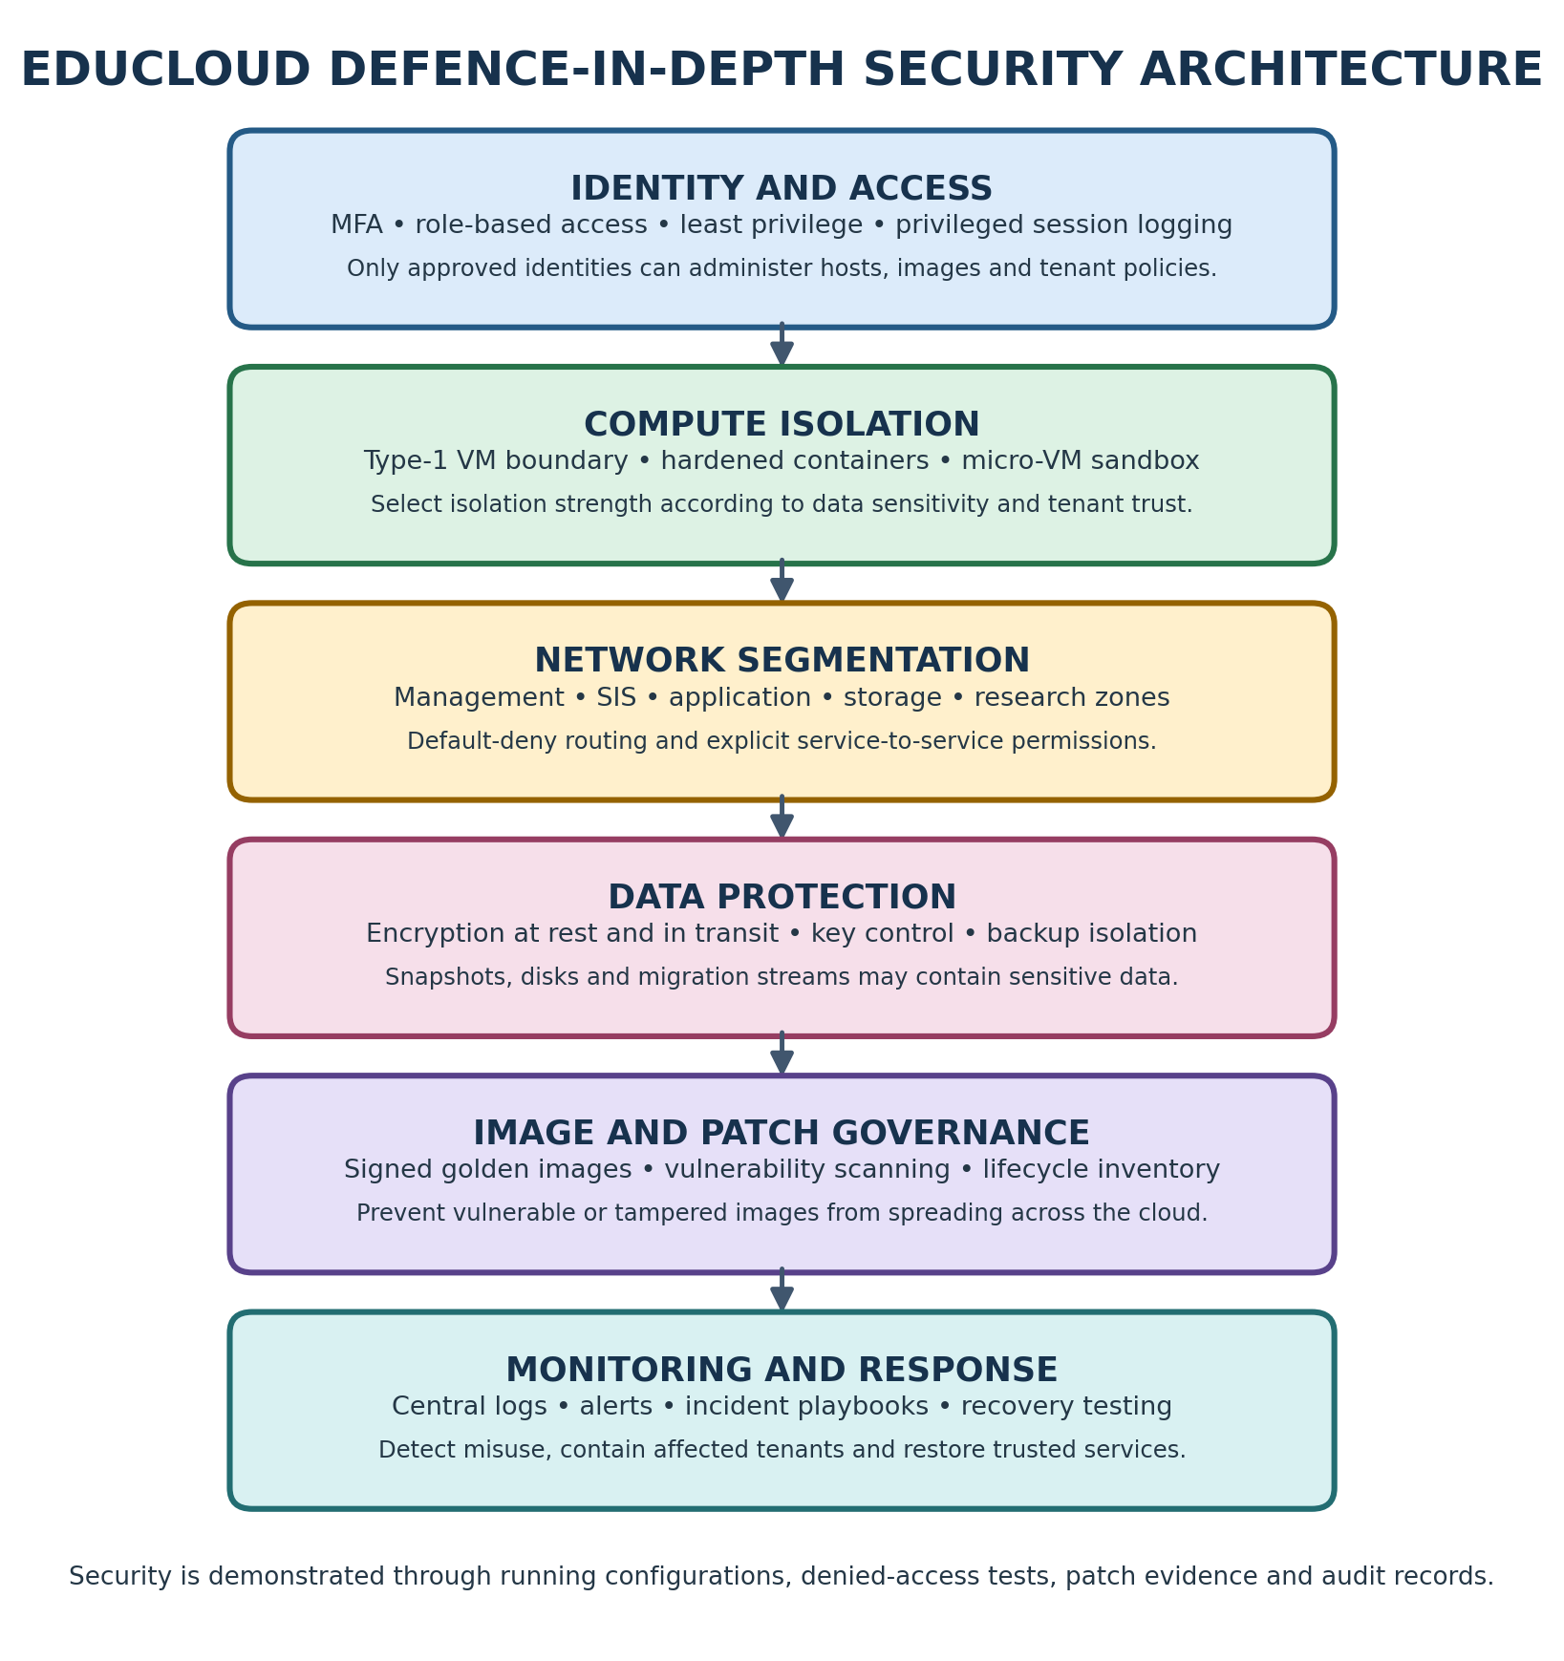
Figure: Detailed colour-coded architecture illustration.

APPENDIX F – CPU SCHEDULING AND OVERCOMMITMENT
A physical CPU core can execute one instruction stream at a time, subject to simultaneous multithreading and processor-specific behaviour. A hypervisor schedules virtual CPUs onto available physical cores. When the total demand is lower than capacity, several configured vCPUs may remain idle and users may see good performance. When all vCPUs become runnable at once, they compete for physical time.
The overcommit ratio is the number of configured virtual CPUs divided by the number of physical cores. At 1:1, 64 physical cores can be assigned 64 vCPUs. At 4:1, the platform may configure 256 vCPUs. This does not create 256 physical cores; it assumes that workloads will not all demand full CPU simultaneously.
A simplified equal-share model estimates the fraction of one physical core available to each runnable vCPU as (1 − h)/r, where h is the assumed virtualization overhead and r is the overcommit ratio. At 4:1 with a 5% overhead assumption, the estimate is 0.95/4 = 0.2375 core equivalents per vCPU under full contention.
This model is useful for understanding the direction of change, but it is not a precise latency predictor. Real scheduling depends on NUMA placement, CPU affinity, cache locality, priority, workload burstiness and SMT. CPU ready or steal time should be measured during the same workload as application latency.
SIS database and authentication workloads are sensitive to tail latency. They should receive reservations and avoid aggressive overcommit. Batch research workloads can use more flexible quotas if their completion-time target permits it.

Worked example and practical interpretation
Worked interpretation: Suppose a host exposes 256 vCPUs at a 4:1 ratio. This is a configuration count, not a promise that 256 physical cores exist. If all 256 vCPUs become runnable together, they must share the 64 physical cores. The resulting waiting time can increase application response time even when the configured vCPU count appears generous. For the SIS login and registration path, a short period of CPU contention can create request timeouts and retries, which can increase load further.

Design implications for EduCloud
Operational decision: Use reservations and conservative overcommit for the database, identity service and other latency-sensitive components. Batch analytics can use lower-priority shares or queued execution when the host is busy. Review CPU ready/steal time together with application p95 latency; high CPU utilization alone does not prove that the scheduler is the bottleneck.

Validation, monitoring and evidence
Validation: Run the same CPU workload at each planned overcommit ratio. Record throughput, p95 completion time, host CPU utilization and ready/steal time. Repeat at least five times. A placement ratio should be accepted only if the measured service objective is maintained during the expected peak, not merely during an idle demonstration.

Practical checklist for the university cloud team
Before approving this component, the cloud team should record its owner, purpose, data classification, tenant boundary, resource request, permitted dependencies and recovery requirement. The configuration should be stored in version control and reviewed before deployment. Administrators should test both normal operation and failure conditions, including a denied cross-tenant request, resource exhaustion, host maintenance and restoration from backup. Results should include timestamps, software versions, configuration values and the exact test procedure. Any limitation must be stated clearly so that an analytical assumption is not mistaken for an observed production result.

APPENDIX G – MEMORY VIRTUALIZATION AND PRESSURE
Each VM is assigned a guest-visible memory size. The hypervisor maps guest memory pages to physical host memory and may use techniques such as ballooning or swapping to manage pressure. Ballooning asks a guest driver to release memory that the host can reclaim. Host swapping moves memory pages to storage, which can produce severe latency when active working sets are swapped.
The assignment gives 512 GB of RAM per host and an average VM demand of 8 GB. Reserving 10% for the host, cache and operating headroom leaves 460.8 GB. Dividing by 8 GB gives 57.6, so the conservative whole-VM planning limit is 57 average-demand VMs per host. The arithmetic ceiling without reserve is 64, but it is not a safe operational target.
Memory demand is not necessarily equal to configured memory. A VM configured with 16 GB may actively use much less, while a database may need its full working set to avoid disk reads. Research workloads may allocate large in-memory datasets and can create sudden pressure.
Containers share the host memory manager. Their memory cgroups provide limits and accounting, but the host kernel and page cache are still shared. A memory limit that is too low may cause an application to be killed; a limit that is too high can permit one tenant to affect others.
Monitoring should include available memory, swap-in/swap-out, major page faults, balloon activity, OOM events and per-workload working set. Admission control should consider the peak working set, not only the average configured amount.

Worked example and practical interpretation
Worked interpretation: With the 10% reserve, the usable planning amount is 460.8 GB. At 8 GB average resident demand, 57 VMs use 456 GB and leave 4.8 GB of the planned usable pool. The 58th VM would require 464 GB and exceed that planning amount. This arithmetic is intentionally conservative; actual placement must also account for VM reservations, host overhead, workload peaks and NUMA layout.

Design implications for EduCloud
Operational decision: Separate configured memory from active working set. A VM configured with 16 GB may use 5 GB during a quiet period but need much more during a report or batch job. Research jobs should declare memory requests and limits. Database workloads should receive sufficient reserved memory to avoid repeated disk reads and should not depend on host swapping for normal operation.

Validation, monitoring and evidence
Validation: Record available memory, working set, major page faults, swap activity, balloon activity and out-of-memory events during the same workload. If memory pressure rises, reduce admission, move workloads to a suitable pool or increase capacity; do not treat ballooning and swapping as free extra RAM.

Practical checklist for the university cloud team
Before approving this component, the cloud team should record its owner, purpose, data classification, tenant boundary, resource request, permitted dependencies and recovery requirement. The configuration should be stored in version control and reviewed before deployment. Administrators should test both normal operation and failure conditions, including a denied cross-tenant request, resource exhaustion, host maintenance and restoration from backup. Results should include timestamps, software versions, configuration values and the exact test procedure. Any limitation must be stated clearly so that an analytical assumption is not mistaken for an observed production result.

APPENDIX H – STORAGE VIRTUALIZATION AND I/O QUEUES
Virtual storage hides the physical disk layout from the guest or container. A VM may see a virtual disk backed by a file, logical volume, SAN LUN or distributed block device. A container may use a layered filesystem and persistent volume. In both cases, multiple workloads eventually compete for physical storage queues and backend bandwidth.
NVMe devices can support many queues, but queue depth and latency still matter. A large number of simultaneous random I/O requests can increase queueing delay. Sequential big-data reads and writes can consume bandwidth and reduce the capacity available to SIS database transactions.
The most useful measurements include IOPS, throughput in MB/s, average latency, p95 latency, queue depth and time spent waiting for I/O. A single maximum-throughput number does not describe the performance of a mixed database and analytics workload.
Use separate storage classes or pools where possible. SIS database volumes should receive predictable performance and appropriate backup protection. Research data should use a separate tenant namespace, quotas and lifecycle rules. Snapshot access should be restricted because a snapshot may contain student records, credentials or encryption metadata.
The assignment does not specify the shared storage backend's measured IOPS or bandwidth. Therefore, this report does not invent a numeric storage-throughput result. The fio experiment in the main report is intended to establish the actual capacity under controlled conditions.

Worked example and practical interpretation
Worked interpretation: If the shared storage backend delivers B IOPS under a defined test and N workloads issue equal demand, B/N is only a first-order equal-share estimate. Real systems use queues and caching, and one random-I/O database workload can experience much higher latency than a sequential research workload even when both report similar throughput. Therefore, IOPS alone is not enough; latency distribution and queue depth must also be recorded.

Design implications for EduCloud
Operational decision: Place SIS database volumes on a storage class with predictable latency and suitable protection. Research datasets should have their own quota, lifecycle and access policy. Snapshot creation, cloning and export must be permission-controlled because snapshots may contain student information, credentials or application state.

Validation, monitoring and evidence
Validation: Run fio with a fixed block size, read/write mix, queue depth, file size and duration. Measure IOPS, MB/s, average latency and p95 latency. Repeat with the noisy-neighbour workload active. Keep the test file away from production data and never run stress tests against the live university datastore without authorization.

Practical checklist for the university cloud team
Before approving this component, the cloud team should record its owner, purpose, data classification, tenant boundary, resource request, permitted dependencies and recovery requirement. The configuration should be stored in version control and reviewed before deployment. Administrators should test both normal operation and failure conditions, including a denied cross-tenant request, resource exhaustion, host maintenance and restoration from backup. Results should include timestamps, software versions, configuration values and the exact test procedure. Any limitation must be stated clearly so that an analytical assumption is not mistaken for an observed production result.

APPENDIX I – NETWORK VIRTUALIZATION AND TRAFFIC CONTROL
A virtual network connects VMs and containers through virtual interfaces, virtual switches, bridges, overlays and physical NICs. The software-defined networking control plane defines forwarding and policy, while the data plane forwards packets. Tenant separation can be implemented using VLANs, overlay identifiers, routing domains, firewall rules and micro-segmentation policies.
Each physical host has two 25 Gbps NICs. Their nominal aggregate line rate is 50 Gbps, but this should not be treated as a guaranteed single-flow throughput. Link aggregation, switch configuration, traffic direction, protocol overhead, packet size and CPU processing affect actual results.
A shared virtual switch can become a bottleneck when packet rates are high or many workloads use small packets. Packet processing consumes CPU cycles, and overlay encapsulation adds processing and packet overhead. Research clusters can generate large east-west traffic flows that compete with SIS application traffic.
Use traffic classes and reservations for critical services. Separate management, storage, SIS, university application and external research networks. Apply ingress and egress policies at tenant boundaries. Restrict collaborator workloads to approved data sources and destinations.
The simple model in Task 3 divides effective aggregate bandwidth by the number of equally active instances. It is only a planning approximation. Actual bandwidth must be measured with iperf3 and correlated with packet drops, retransmissions, CPU use and p95 application latency.

Worked example and practical interpretation
Worked interpretation: Suppose a host exposes 256 vCPUs at a 4:1 ratio. This is a configuration count, not a promise that 256 physical cores exist. If all 256 vCPUs become runnable together, they must share the 64 physical cores. The resulting waiting time can increase application response time even when the configured vCPU count appears generous. For the SIS login and registration path, a short period of CPU contention can create request timeouts and retries, which can increase load further.

Design implications for EduCloud
Operational decision: Use reservations and conservative overcommit for the database, identity service and other latency-sensitive components. Batch analytics can use lower-priority shares or queued execution when the host is busy. Review CPU ready/steal time together with application p95 latency; high CPU utilization alone does not prove that the scheduler is the bottleneck.

Validation, monitoring and evidence
Validation: Run the same CPU workload at each planned overcommit ratio. Record throughput, p95 completion time, host CPU utilization and ready/steal time. Repeat at least five times. A placement ratio should be accepted only if the measured service objective is maintained during the expected peak, not merely during an idle demonstration.

Practical checklist for the university cloud team
Before approving this component, the cloud team should record its owner, purpose, data classification, tenant boundary, resource request, permitted dependencies and recovery requirement. The configuration should be stored in version control and reviewed before deployment. Administrators should test both normal operation and failure conditions, including a denied cross-tenant request, resource exhaustion, host maintenance and restoration from backup. Results should include timestamps, software versions, configuration values and the exact test procedure. Any limitation must be stated clearly so that an analytical assumption is not mistaken for an observed production result.

APPENDIX J – DOMINANT OVERHEAD: VM EXITS AND PAGE WALKS
A VM exit occurs when a guest operation requires the hypervisor or host to regain control. Examples include certain privileged operations, interrupts, emulated device access and operations that cannot be completed directly in guest mode. The processor saves relevant state, transfers control and later resumes the guest. Each transition adds latency.
The assignment supplies an assumed VM-exit cost of 1.5 microseconds. If a workload triggers E exits per second, a simple estimate of time spent on exits is E × 1.5 microseconds per second. For example, 100,000 exits per second would consume approximately 0.15 seconds of CPU time per second if the assumed cost applied to every exit. This is a simplified arithmetic illustration, not a measured EduCloud result.
Memory translation can also add work. With EPT/NPT, the processor translates guest addresses through guest and host mappings. Translation lookaside buffers reduce repeated walks, but cache misses and memory pressure can make page walks more expensive.
As the number of co-located VMs rises, the number of exits may increase because of more device activity and scheduling events. Memory working sets can also compete for translation caches. The dominant factor should be identified using available hypervisor counters and workload profiling rather than assumed from architecture labels alone.
For EduCloud, use paravirtualized drivers where supported, reduce unnecessary virtual devices and avoid excessive overcommit for latency-sensitive VMs.

Worked example and practical interpretation
Worked interpretation: Suppose a host exposes 256 vCPUs at a 4:1 ratio. This is a configuration count, not a promise that 256 physical cores exist. If all 256 vCPUs become runnable together, they must share the 64 physical cores. The resulting waiting time can increase application response time even when the configured vCPU count appears generous. For the SIS login and registration path, a short period of CPU contention can create request timeouts and retries, which can increase load further.

Design implications for EduCloud
Operational decision: Use reservations and conservative overcommit for the database, identity service and other latency-sensitive components. Batch analytics can use lower-priority shares or queued execution when the host is busy. Review CPU ready/steal time together with application p95 latency; high CPU utilization alone does not prove that the scheduler is the bottleneck.

Validation, monitoring and evidence
Validation: Run the same CPU workload at each planned overcommit ratio. Record throughput, p95 completion time, host CPU utilization and ready/steal time. Repeat at least five times. A placement ratio should be accepted only if the measured service objective is maintained during the expected peak, not merely during an idle demonstration.

Practical checklist for the university cloud team
Before approving this component, the cloud team should record its owner, purpose, data classification, tenant boundary, resource request, permitted dependencies and recovery requirement. The configuration should be stored in version control and reviewed before deployment. Administrators should test both normal operation and failure conditions, including a denied cross-tenant request, resource exhaustion, host maintenance and restoration from backup. Results should include timestamps, software versions, configuration values and the exact test procedure. Any limitation must be stated clearly so that an analytical assumption is not mistaken for an observed production result.

APPENDIX K – DOMINANT OVERHEAD: CONTAINER SYSTEM CALLS
A system call transfers execution from an application running in user mode into the operating-system kernel. The assignment gives a native system-call cost of 0.2 microseconds. If a workload performs S system calls per second, the simplified baseline time associated with those calls is S × 0.2 microseconds per second.
A normal container generally uses the host kernel directly, so a system call does not automatically pass through a hypervisor. However, namespaces, security checks, cgroups, filesystem layers and virtual networking can add work around the system call. A sandboxed runtime may intercept or emulate a larger subset of system calls, which can increase cost for syscall-heavy workloads.
For example, a service that performs many small file operations may be more affected by filesystem-layer overhead than a CPU-bound program that performs calculations in user space. Similarly, a high-rate network service can spend substantial time in socket operations, packet processing and virtual-switch paths.
The correct comparison uses identical binaries, data, limits and repetition counts. Measure system-call rate where practical, CPU time, context switches, throughput and latency. Avoid interpreting the 0.2 microsecond assignment assumption as a universal value for all processors or kernels.
For EduCloud, standard containers are suitable for trusted internal APIs after host-kernel hardening. External research code should receive a stronger sandbox or VM boundary even if that boundary adds some overhead.

Worked example and practical interpretation
Worked interpretation: Suppose a host exposes 256 vCPUs at a 4:1 ratio. This is a configuration count, not a promise that 256 physical cores exist. If all 256 vCPUs become runnable together, they must share the 64 physical cores. The resulting waiting time can increase application response time even when the configured vCPU count appears generous. For the SIS login and registration path, a short period of CPU contention can create request timeouts and retries, which can increase load further.

Design implications for EduCloud
Operational decision: Use reservations and conservative overcommit for the database, identity service and other latency-sensitive components. Batch analytics can use lower-priority shares or queued execution when the host is busy. Review CPU ready/steal time together with application p95 latency; high CPU utilization alone does not prove that the scheduler is the bottleneck.

Validation, monitoring and evidence
Validation: Run the same CPU workload at each planned overcommit ratio. Record throughput, p95 completion time, host CPU utilization and ready/steal time. Repeat at least five times. A placement ratio should be accepted only if the measured service objective is maintained during the expected peak, not merely during an idle demonstration.

Practical checklist for the university cloud team
Before approving this component, the cloud team should record its owner, purpose, data classification, tenant boundary, resource request, permitted dependencies and recovery requirement. The configuration should be stored in version control and reviewed before deployment. Administrators should test both normal operation and failure conditions, including a denied cross-tenant request, resource exhaustion, host maintenance and restoration from backup. Results should include timestamps, software versions, configuration values and the exact test procedure. Any limitation must be stated clearly so that an analytical assumption is not mistaken for an observed production result.

APPENDIX L – PERFORMANCE QUEUEING AND TAIL LATENCY
A service can have acceptable average latency while still producing a poor user experience. The 95th percentile latency describes the time within which 95% of requests complete; it helps reveal slow requests that are hidden by an average. Registration and login workflows are especially sensitive because a small number of slow authentication or database requests can cause retries and failed sessions.
Queueing occurs when requests arrive faster than a component can process them. CPU run queues, storage queues, network transmit queues and database connection pools can all accumulate work. As utilization approaches saturation, a small increase in demand can produce a disproportionate increase in waiting time.
The EduCloud scenario reports slow responses and failed logins during registration week. Possible causes include CPU ready time, database locks, storage latency, authentication-service saturation, DNS delays, connection-pool exhaustion or packet loss. The symptom alone does not identify the cause.
Collect correlated metrics with synchronized timestamps. For each service, record request rate, error rate, mean latency and p95 latency. At the host, record CPU utilization, steal/ready time, memory pressure, storage queue depth and network drops. At the database, record active connections, lock waits and query latency.
A good mitigation addresses the saturated resource. Adding web replicas will not fix a database bottleneck unless database capacity or query behaviour is also addressed.

Worked example and practical interpretation
Worked interpretation: Suppose a host exposes 256 vCPUs at a 4:1 ratio. This is a configuration count, not a promise that 256 physical cores exist. If all 256 vCPUs become runnable together, they must share the 64 physical cores. The resulting waiting time can increase application response time even when the configured vCPU count appears generous. For the SIS login and registration path, a short period of CPU contention can create request timeouts and retries, which can increase load further.

Design implications for EduCloud
Operational decision: Use reservations and conservative overcommit for the database, identity service and other latency-sensitive components. Batch analytics can use lower-priority shares or queued execution when the host is busy. Review CPU ready/steal time together with application p95 latency; high CPU utilization alone does not prove that the scheduler is the bottleneck.

Validation, monitoring and evidence
Validation: Run the same CPU workload at each planned overcommit ratio. Record throughput, p95 completion time, host CPU utilization and ready/steal time. Repeat at least five times. A placement ratio should be accepted only if the measured service objective is maintained during the expected peak, not merely during an idle demonstration.

Practical checklist for the university cloud team
Before approving this component, the cloud team should record its owner, purpose, data classification, tenant boundary, resource request, permitted dependencies and recovery requirement. The configuration should be stored in version control and reviewed before deployment. Administrators should test both normal operation and failure conditions, including a denied cross-tenant request, resource exhaustion, host maintenance and restoration from backup. Results should include timestamps, software versions, configuration values and the exact test procedure. Any limitation must be stated clearly so that an analytical assumption is not mistaken for an observed production result.

APPENDIX M – BEST-CASE PLACEMENT AND NUMA
Modern servers may divide memory and processors into Non-Uniform Memory Access (NUMA) nodes. A CPU core can access memory attached to its local node more quickly than memory attached to another node. A VM or container that is poorly placed may frequently access remote memory, increasing latency and consuming interconnect bandwidth.
Best-case placement keeps a workload's vCPUs and memory close to the same NUMA node where possible. It avoids unnecessary vCPU overcommit, uses efficient virtual I/O drivers, keeps storage queues within planned limits and avoids noisy neighbours. Containers benefit from CPU and memory affinity when the workload is predictable.
For database workloads, memory locality and storage latency can be as important as total CPU count. For distributed research workloads, network topology and data locality can influence job completion time. A Spark task that repeatedly transfers data across hosts may consume network bandwidth that would otherwise serve university applications.
The platform should document host topology and use NUMA-aware placement for large VMs. Before pinning CPUs, administrators should understand the trade-off: strict pinning can improve predictability but reduce scheduler flexibility and make capacity fragmentation worse.
The best-case analysis should be verified by running the same benchmark with and without NUMA-aware placement. Record throughput, p95 latency, CPU utilization and remote-memory indicators if available.

Worked example and practical interpretation
Worked interpretation: Suppose a host exposes 256 vCPUs at a 4:1 ratio. This is a configuration count, not a promise that 256 physical cores exist. If all 256 vCPUs become runnable together, they must share the 64 physical cores. The resulting waiting time can increase application response time even when the configured vCPU count appears generous. For the SIS login and registration path, a short period of CPU contention can create request timeouts and retries, which can increase load further.

Design implications for EduCloud
Operational decision: Use reservations and conservative overcommit for the database, identity service and other latency-sensitive components. Batch analytics can use lower-priority shares or queued execution when the host is busy. Review CPU ready/steal time together with application p95 latency; high CPU utilization alone does not prove that the scheduler is the bottleneck.

Validation, monitoring and evidence
Validation: Run the same CPU workload at each planned overcommit ratio. Record throughput, p95 completion time, host CPU utilization and ready/steal time. Repeat at least five times. A placement ratio should be accepted only if the measured service objective is maintained during the expected peak, not merely during an idle demonstration.

Practical checklist for the university cloud team
Before approving this component, the cloud team should record its owner, purpose, data classification, tenant boundary, resource request, permitted dependencies and recovery requirement. The configuration should be stored in version control and reviewed before deployment. Administrators should test both normal operation and failure conditions, including a denied cross-tenant request, resource exhaustion, host maintenance and restoration from backup. Results should include timestamps, software versions, configuration values and the exact test procedure. Any limitation must be stated clearly so that an analytical assumption is not mistaken for an observed production result.

APPENDIX N – TYPICAL REGISTRATION-WEEK WORKLOAD
Registration week combines many different request types. Students authenticate, load course lists, submit registration changes, check fee status and retrieve confirmation pages. Staff may run reports and resolve exceptions. The SIS database receives both read and write requests, while the web and authentication tiers handle many short-lived connections.
The workload is bursty. A large number of users may log in at the same time when registration opens. This creates a surge in authentication requests, database connections and session lookups. If all services share a host pool without resource reservations, background tasks can compete with the critical request path.
A typical workload test should reproduce a mixture of reads and writes rather than a single CPU benchmark. Use a representative request mix, realistic data size and controlled arrival rate. Include a login-like request sequence if a safe test application is available. Measure successful request rate, error rate, mean latency and p95 latency.
Separate stateless web/API replicas from stateful database services. Stateless services can scale horizontally, but database connections and storage I/O require independent capacity planning. Use connection pooling and caching carefully, ensuring that cache invalidation and authorization do not expose one student's data to another.
The performance target should be expressed as a service-level objective, such as maximum p95 response time and maximum error rate, not only host CPU utilization.

Worked example and practical interpretation
Worked interpretation: Suppose a host exposes 256 vCPUs at a 4:1 ratio. This is a configuration count, not a promise that 256 physical cores exist. If all 256 vCPUs become runnable together, they must share the 64 physical cores. The resulting waiting time can increase application response time even when the configured vCPU count appears generous. For the SIS login and registration path, a short period of CPU contention can create request timeouts and retries, which can increase load further.

Design implications for EduCloud
Operational decision: Use reservations and conservative overcommit for the database, identity service and other latency-sensitive components. Batch analytics can use lower-priority shares or queued execution when the host is busy. Review CPU ready/steal time together with application p95 latency; high CPU utilization alone does not prove that the scheduler is the bottleneck.

Validation, monitoring and evidence
Validation: Run the same CPU workload at each planned overcommit ratio. Record throughput, p95 completion time, host CPU utilization and ready/steal time. Repeat at least five times. A placement ratio should be accepted only if the measured service objective is maintained during the expected peak, not merely during an idle demonstration.

Practical checklist for the university cloud team
Before approving this component, the cloud team should record its owner, purpose, data classification, tenant boundary, resource request, permitted dependencies and recovery requirement. The configuration should be stored in version control and reviewed before deployment. Administrators should test both normal operation and failure conditions, including a denied cross-tenant request, resource exhaustion, host maintenance and restoration from backup. Results should include timestamps, software versions, configuration values and the exact test procedure. Any limitation must be stated clearly so that an analytical assumption is not mistaken for an observed production result.

APPENDIX O – WORST-CASE NOISY-NEIGHBOUR SCENARIO
A noisy neighbour is a workload that consumes a disproportionate share of a shared resource and degrades the performance of other tenants. It may use CPU continuously, allocate most available memory, issue heavy random I/O or transmit large volumes of network traffic.
In EduCloud, a departmental research job could saturate CPU or storage while SIS is serving registration requests. Even if each VM is logically isolated, the physical resources remain shared. A hypervisor can prevent one VM from reading another VM's memory, but it cannot create additional physical CPU cycles or storage bandwidth.
Resource controls should be applied at several layers. CPU reservations and shares protect critical services. Memory reservations and limits reduce the risk of host swapping. Storage QoS and separate storage pools reduce I/O interference. Network rate limits and traffic classes protect important flows. Monitoring should alert on sustained contention and p95 latency degradation.
The noisy-neighbour experiment should use a fixed victim workload and a controlled stressor. First measure the victim alone. Then run the stressor on another instance while keeping the victim's request rate constant. Repeat the experiment and compare mean and p95 latency, throughput, CPU ready time, I/O latency and network drops.
Do not run this test on production infrastructure without authorization. Use an isolated test host and record the exact configuration so the experiment can be repeated.

Worked example and practical interpretation
Worked interpretation: Suppose a host exposes 256 vCPUs at a 4:1 ratio. This is a configuration count, not a promise that 256 physical cores exist. If all 256 vCPUs become runnable together, they must share the 64 physical cores. The resulting waiting time can increase application response time even when the configured vCPU count appears generous. For the SIS login and registration path, a short period of CPU contention can create request timeouts and retries, which can increase load further.

Design implications for EduCloud
Operational decision: Use reservations and conservative overcommit for the database, identity service and other latency-sensitive components. Batch analytics can use lower-priority shares or queued execution when the host is busy. Review CPU ready/steal time together with application p95 latency; high CPU utilization alone does not prove that the scheduler is the bottleneck.

Validation, monitoring and evidence
Validation: Run the same CPU workload at each planned overcommit ratio. Record throughput, p95 completion time, host CPU utilization and ready/steal time. Repeat at least five times. A placement ratio should be accepted only if the measured service objective is maintained during the expected peak, not merely during an idle demonstration.

Practical checklist for the university cloud team
Before approving this component, the cloud team should record its owner, purpose, data classification, tenant boundary, resource request, permitted dependencies and recovery requirement. The configuration should be stored in version control and reviewed before deployment. Administrators should test both normal operation and failure conditions, including a denied cross-tenant request, resource exhaustion, host maintenance and restoration from backup. Results should include timestamps, software versions, configuration values and the exact test procedure. Any limitation must be stated clearly so that an analytical assumption is not mistaken for an observed production result.

APPENDIX P – VM ESCAPE AND CONTAINER ESCAPE
A VM escape is an attack in which code running inside a guest gains unauthorized access to the hypervisor or host. Possible paths include vulnerabilities in virtual device emulation, hypervisor interfaces or management components. A successful escape can undermine the isolation between tenants and may expose host resources.
A container escape occurs when a process inside a container gains access beyond its intended namespace or privilege boundary. Because containers share the host kernel, kernel vulnerabilities, excessive capabilities, privileged mode or unsafe host mounts can increase risk.
The two threats are related but not identical. A VM normally has a separate guest kernel and virtual hardware boundary; a container normally shares the host kernel. This gives containers lower startup and memory overhead but makes host-kernel security especially important.
Controls include minimizing exposed virtual devices, patching hypervisors and host kernels, disabling unnecessary services, avoiding privileged containers, dropping Linux capabilities, applying seccomp and mandatory access control, and restricting management interfaces. Use signed images and scan them before deployment.
The likely impact includes confidentiality loss if student records or credentials are exposed, integrity loss if records are modified, and availability loss if the host or critical service is compromised. Incident response should include isolation of the affected workload, preservation of logs, credential rotation and recovery from trusted images.

Worked example and practical interpretation
Worked interpretation: Suppose a host exposes 256 vCPUs at a 4:1 ratio. This is a configuration count, not a promise that 256 physical cores exist. If all 256 vCPUs become runnable together, they must share the 64 physical cores. The resulting waiting time can increase application response time even when the configured vCPU count appears generous. For the SIS login and registration path, a short period of CPU contention can create request timeouts and retries, which can increase load further.

Design implications for EduCloud
Operational decision: Use reservations and conservative overcommit for the database, identity service and other latency-sensitive components. Batch analytics can use lower-priority shares or queued execution when the host is busy. Review CPU ready/steal time together with application p95 latency; high CPU utilization alone does not prove that the scheduler is the bottleneck.

Validation, monitoring and evidence
Validation: Run the same CPU workload at each planned overcommit ratio. Record throughput, p95 completion time, host CPU utilization and ready/steal time. Repeat at least five times. A placement ratio should be accepted only if the measured service objective is maintained during the expected peak, not merely during an idle demonstration.

Practical checklist for the university cloud team
Before approving this component, the cloud team should record its owner, purpose, data classification, tenant boundary, resource request, permitted dependencies and recovery requirement. The configuration should be stored in version control and reviewed before deployment. Administrators should test both normal operation and failure conditions, including a denied cross-tenant request, resource exhaustion, host maintenance and restoration from backup. Results should include timestamps, software versions, configuration values and the exact test procedure. Any limitation must be stated clearly so that an analytical assumption is not mistaken for an observed production result.

APPENDIX Q – SIDE-CHANNEL ATTACKS AND CO-RESIDENCY
A side-channel attack attempts to infer information through indirect observations such as execution timing, cache behaviour, branch prediction or resource contention. It may not require direct access to another tenant's memory. Shared physical processors can expose some common microarchitectural resources even when the hypervisor correctly enforces memory separation.
Co-residency means workloads from different tenants execute on the same physical host. This can increase the possibility of shared-resource interference and side-channel observation. Disabling simultaneous multithreading, separating sensitive tenants onto dedicated hosts and applying processor security updates can reduce some risks, but no single mitigation eliminates every side channel.
The security decision should be based on the sensitivity of the data and the threat model. SIS database workloads contain personal and academic records, so stronger placement controls are justified. External collaborators should not be placed on the same physical hosts as the SIS database when demonstrable isolation is required.
Performance cost must be measured. Disabling SMT can reduce available logical CPU capacity. Dedicated hosts reduce density and may increase hardware cost. These costs should be compared with the consequences of a cross-tenant information leak.
Document the placement policy, host membership, administrator approvals and periodic compliance checks. A policy that exists only in a design document is not demonstrable isolation; the platform must provide evidence that placement rules are enforced.

Worked example and practical interpretation
Worked interpretation: Suppose a host exposes 256 vCPUs at a 4:1 ratio. This is a configuration count, not a promise that 256 physical cores exist. If all 256 vCPUs become runnable together, they must share the 64 physical cores. The resulting waiting time can increase application response time even when the configured vCPU count appears generous. For the SIS login and registration path, a short period of CPU contention can create request timeouts and retries, which can increase load further.

Design implications for EduCloud
Operational decision: Use reservations and conservative overcommit for the database, identity service and other latency-sensitive components. Batch analytics can use lower-priority shares or queued execution when the host is busy. Review CPU ready/steal time together with application p95 latency; high CPU utilization alone does not prove that the scheduler is the bottleneck.

Validation, monitoring and evidence
Validation: Run the same CPU workload at each planned overcommit ratio. Record throughput, p95 completion time, host CPU utilization and ready/steal time. Repeat at least five times. A placement ratio should be accepted only if the measured service objective is maintained during the expected peak, not merely during an idle demonstration.

Practical checklist for the university cloud team
Before approving this component, the cloud team should record its owner, purpose, data classification, tenant boundary, resource request, permitted dependencies and recovery requirement. The configuration should be stored in version control and reviewed before deployment. Administrators should test both normal operation and failure conditions, including a denied cross-tenant request, resource exhaustion, host maintenance and restoration from backup. Results should include timestamps, software versions, configuration values and the exact test procedure. Any limitation must be stated clearly so that an analytical assumption is not mistaken for an observed production result.

APPENDIX R – IMAGE TAMPERING, SNAPSHOTS AND VM SPRAWL
A VM image is a template used to create a virtual machine. It may contain an operating system, installed software, configuration files and sometimes credentials or data. If teams copy images freely, the university can lose track of which versions exist, who can access them and whether they contain sensitive information.
Image tampering occurs when an attacker modifies an image or replaces it with a malicious version. A vulnerable image may also be copied repeatedly, causing an outdated kernel or package to spread across the environment. VM sprawl occurs when unused or forgotten VMs remain active or retain data and credentials.
A controlled image pipeline should start from approved base images. Build automation should pin package versions, scan for vulnerabilities, detect secrets and produce a signed artifact. The registry should enforce role-based access and immutable digests. Deployments should record the exact image version and owner.
Snapshots require special care. A snapshot can capture memory state, disks and configuration. It may include tokens, encryption keys or student records. Snapshot creation, export, copying and deletion should be logged and restricted. Retention periods should be defined, and sensitive snapshots should be encrypted.
A periodic inventory should identify owners, business purpose, guest OS version, patch status, image provenance and last-used date. Retire unused resources safely and securely erase associated storage according to university policy.

Worked example and practical interpretation
Worked interpretation: With the 10% reserve, the usable planning amount is 460.8 GB. At 8 GB average resident demand, 57 VMs use 456 GB and leave 4.8 GB of the planned usable pool. The 58th VM would require 464 GB and exceed that planning amount. This arithmetic is intentionally conservative; actual placement must also account for VM reservations, host overhead, workload peaks and NUMA layout.

Design implications for EduCloud
Operational decision: Separate configured memory from active working set. A VM configured with 16 GB may use 5 GB during a quiet period but need much more during a report or batch job. Research jobs should declare memory requests and limits. Database workloads should receive sufficient reserved memory to avoid repeated disk reads and should not depend on host swapping for normal operation.

Validation, monitoring and evidence
Validation: Record available memory, working set, major page faults, swap activity, balloon activity and out-of-memory events during the same workload. If memory pressure rises, reduce admission, move workloads to a suitable pool or increase capacity; do not treat ballooning and swapping as free extra RAM.

Practical checklist for the university cloud team
Before approving this component, the cloud team should record its owner, purpose, data classification, tenant boundary, resource request, permitted dependencies and recovery requirement. The configuration should be stored in version control and reviewed before deployment. Administrators should test both normal operation and failure conditions, including a denied cross-tenant request, resource exhaustion, host maintenance and restoration from backup. Results should include timestamps, software versions, configuration values and the exact test procedure. Any limitation must be stated clearly so that an analytical assumption is not mistaken for an observed production result.

COLOUR ARCHITECTURE DIAGRAM – R – IMAGE TAMPERING, SNAPSHOTS AND VM SPRAWL
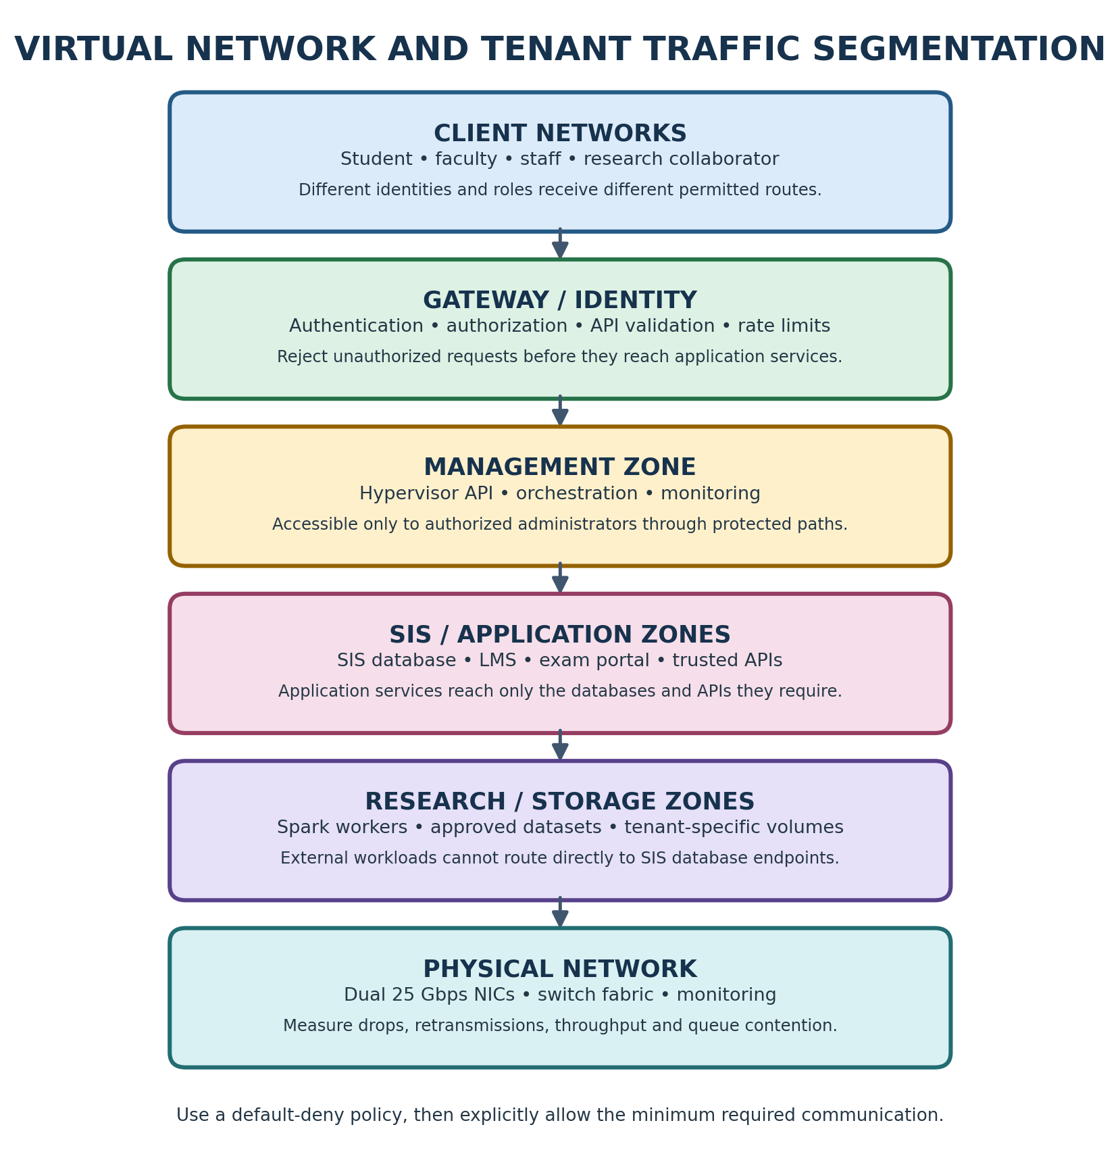
Figure: Detailed colour-coded architecture illustration.

APPENDIX S – VIRTUAL NETWORK THREATS
A virtual network can connect workloads that are physically located on the same host or on different hosts. Misconfiguration can allow one tenant to observe or reach another tenant's traffic. Common risks include promiscuous-mode exposure, spoofed addresses, weak overlay policies, flat networks and excessive east-west access.
Network sniffing can expose unencrypted credentials or student information. Spoofing can allow an attacker to impersonate another endpoint or redirect traffic. Lateral movement can occur when a compromised workload can reach management services or databases that it does not need.
The university should separate management, storage, SIS, application, departmental and external research networks. Use tenant-specific network identifiers and firewall rules. Restrict traffic by source identity, destination, protocol and port. Apply encryption to sensitive traffic and authenticate service-to-service connections.
Network policy should be tested, not merely documented. A test tenant should attempt to reach a protected SIS endpoint and receive a denial. Authorized SIS application traffic should still succeed. Record the policy, source and destination, test time and logs as evidence.
For Spark/Hadoop, allow only the necessary cluster communication and data access paths. External research workloads should not be able to discover or connect to SIS database interfaces. Monitoring should identify unexpected traffic, denied connections and unusual data transfer volumes.

Worked example and practical interpretation
Worked interpretation: If the shared storage backend delivers B IOPS under a defined test and N workloads issue equal demand, B/N is only a first-order equal-share estimate. Real systems use queues and caching, and one random-I/O database workload can experience much higher latency than a sequential research workload even when both report similar throughput. Therefore, IOPS alone is not enough; latency distribution and queue depth must also be recorded.

Design implications for EduCloud
Operational decision: Place SIS database volumes on a storage class with predictable latency and suitable protection. Research datasets should have their own quota, lifecycle and access policy. Snapshot creation, cloning and export must be permission-controlled because snapshots may contain student information, credentials or application state.

Validation, monitoring and evidence
Validation: Run fio with a fixed block size, read/write mix, queue depth, file size and duration. Measure IOPS, MB/s, average latency and p95 latency. Repeat with the noisy-neighbour workload active. Keep the test file away from production data and never run stress tests against the live university datastore without authorization.

Practical checklist for the university cloud team
Before approving this component, the cloud team should record its owner, purpose, data classification, tenant boundary, resource request, permitted dependencies and recovery requirement. The configuration should be stored in version control and reviewed before deployment. Administrators should test both normal operation and failure conditions, including a denied cross-tenant request, resource exhaustion, host maintenance and restoration from backup. Results should include timestamps, software versions, configuration values and the exact test procedure. Any limitation must be stated clearly so that an analytical assumption is not mistaken for an observed production result.

APPENDIX T – SECURE LIVE MIGRATION
Live migration moves a running VM from one physical host to another while attempting to minimize service interruption. The source host transfers memory pages and device state to the destination. Pages modified during copying may need to be copied again. Eventually, the VM is paused briefly, final state is transferred and execution resumes at the destination.
Migration consumes CPU, memory bandwidth and network bandwidth. If several VMs migrate at once, the migration traffic can compete with application traffic and storage replication. This is particularly important when big-data workloads are already using the network heavily.
Security is equally important. Migration data may contain memory pages with credentials, tokens and personal information. The source and destination must authenticate each other, and the migration channel should be encrypted. Access to migration controls should be limited to authorized administrators and all actions should be audited.
Before migration, check destination capacity, CPU compatibility, network reachability, storage access and policy compliance. Do not migrate a sensitive SIS VM into an external research host pool. The placement policy must be enforced during both normal operation and maintenance.
Schedule planned patch migrations outside registration peaks. If an emergency migration is required, prioritize critical services, reserve bandwidth and monitor application latency. After migration, verify VM health, network policy, storage access and application-level transactions. Maintain a rollback plan.

Worked example and practical interpretation
Worked interpretation: Suppose a host exposes 256 vCPUs at a 4:1 ratio. This is a configuration count, not a promise that 256 physical cores exist. If all 256 vCPUs become runnable together, they must share the 64 physical cores. The resulting waiting time can increase application response time even when the configured vCPU count appears generous. For the SIS login and registration path, a short period of CPU contention can create request timeouts and retries, which can increase load further.

Design implications for EduCloud
Operational decision: Use reservations and conservative overcommit for the database, identity service and other latency-sensitive components. Batch analytics can use lower-priority shares or queued execution when the host is busy. Review CPU ready/steal time together with application p95 latency; high CPU utilization alone does not prove that the scheduler is the bottleneck.

Validation, monitoring and evidence
Validation: Run the same CPU workload at each planned overcommit ratio. Record throughput, p95 completion time, host CPU utilization and ready/steal time. Repeat at least five times. A placement ratio should be accepted only if the measured service objective is maintained during the expected peak, not merely during an idle demonstration.

Practical checklist for the university cloud team
Before approving this component, the cloud team should record its owner, purpose, data classification, tenant boundary, resource request, permitted dependencies and recovery requirement. The configuration should be stored in version control and reviewed before deployment. Administrators should test both normal operation and failure conditions, including a denied cross-tenant request, resource exhaustion, host maintenance and restoration from backup. Results should include timestamps, software versions, configuration values and the exact test procedure. Any limitation must be stated clearly so that an analytical assumption is not mistaken for an observed production result.

APPENDIX U – ENCRYPTION, IDENTITY AND ACCESS CONTROL
Encryption protects data when it is stored and when it moves between components. Storage encryption helps protect disks, backups and snapshots if the underlying media or files are exposed. Transport encryption protects traffic between clients, APIs, databases, storage services and migration endpoints.
Encryption alone does not determine who may access data. Identity and access management assigns identities to users, services and administrators. Role-based access control grants permissions according to job responsibilities. Least privilege means a service or person receives only the access needed to perform its task.
SIS access should be checked at the application and data layers. A student should see only their own records. A staff member should receive permissions appropriate to their role. An external research collaborator should not receive SIS database credentials or broad access to shared storage.
Use MFA for privileged accounts, short-lived service credentials where possible, secret rotation and audited administrative sessions. Avoid embedding secrets in VM images, container layers or source repositories. Keep key-management responsibilities separate from ordinary workload administration.
Evidence should include access-control policy, key-management configuration, encryption status, audit logs and periodic access reviews. The university should test both permitted and denied access paths to verify that the controls operate as intended.

Worked example and practical interpretation
Worked interpretation: If the shared storage backend delivers B IOPS under a defined test and N workloads issue equal demand, B/N is only a first-order equal-share estimate. Real systems use queues and caching, and one random-I/O database workload can experience much higher latency than a sequential research workload even when both report similar throughput. Therefore, IOPS alone is not enough; latency distribution and queue depth must also be recorded.

Design implications for EduCloud
Operational decision: Place SIS database volumes on a storage class with predictable latency and suitable protection. Research datasets should have their own quota, lifecycle and access policy. Snapshot creation, cloning and export must be permission-controlled because snapshots may contain student information, credentials or application state.

Validation, monitoring and evidence
Validation: Run fio with a fixed block size, read/write mix, queue depth, file size and duration. Measure IOPS, MB/s, average latency and p95 latency. Repeat with the noisy-neighbour workload active. Keep the test file away from production data and never run stress tests against the live university datastore without authorization.

Practical checklist for the university cloud team
Before approving this component, the cloud team should record its owner, purpose, data classification, tenant boundary, resource request, permitted dependencies and recovery requirement. The configuration should be stored in version control and reviewed before deployment. Administrators should test both normal operation and failure conditions, including a denied cross-tenant request, resource exhaustion, host maintenance and restoration from backup. Results should include timestamps, software versions, configuration values and the exact test procedure. Any limitation must be stated clearly so that an analytical assumption is not mistaken for an observed production result.

APPENDIX V – EXPERIMENTAL METHOD AND FAIR COMPARISON
A fair performance comparison changes one factor at a time. The three approaches should run on the same host hardware, with the same number of instances, CPU allocation, memory allocation, disk size, network path, workload version and test duration. If the hardware is shared or the laptop is constrained, the limitation must be recorded.
Each test should include a warm-up period followed by at least five measured repetitions. Record the mean and standard deviation. If a result varies widely, investigate background processes, CPU frequency changes, thermal throttling, cache state and storage cache effects.
The bare-metal baseline should run the same workload directly on the host where safe and appropriate. Performance degradation can then be calculated as (baseline throughput − virtualized throughput) divided by baseline throughput, multiplied by 100. For latency, compare the virtualized latency with the baseline latency using a clearly stated formula.
The test matrix should include CPU, disk, network and memory workloads. A noisy-neighbour experiment should measure a victim service with and without a separate stress workload. Security validation should inspect a property such as namespaces, cgroup limits, kernel sharing, image signature verification or tenant network denial.
Do not mix model estimates with observed measurements. Label each table clearly. If a test cannot be completed because the laptop does not support nested virtualization or lacks sufficient RAM, state the limitation and reduce the scale proportionally.

Worked example and practical interpretation
Worked interpretation: Suppose a host exposes 256 vCPUs at a 4:1 ratio. This is a configuration count, not a promise that 256 physical cores exist. If all 256 vCPUs become runnable together, they must share the 64 physical cores. The resulting waiting time can increase application response time even when the configured vCPU count appears generous. For the SIS login and registration path, a short period of CPU contention can create request timeouts and retries, which can increase load further.

Design implications for EduCloud
Operational decision: Use reservations and conservative overcommit for the database, identity service and other latency-sensitive components. Batch analytics can use lower-priority shares or queued execution when the host is busy. Review CPU ready/steal time together with application p95 latency; high CPU utilization alone does not prove that the scheduler is the bottleneck.

Validation, monitoring and evidence
Validation: Run the same CPU workload at each planned overcommit ratio. Record throughput, p95 completion time, host CPU utilization and ready/steal time. Repeat at least five times. A placement ratio should be accepted only if the measured service objective is maintained during the expected peak, not merely during an idle demonstration.

Practical checklist for the university cloud team
Before approving this component, the cloud team should record its owner, purpose, data classification, tenant boundary, resource request, permitted dependencies and recovery requirement. The configuration should be stored in version control and reviewed before deployment. Administrators should test both normal operation and failure conditions, including a denied cross-tenant request, resource exhaustion, host maintenance and restoration from backup. Results should include timestamps, software versions, configuration values and the exact test procedure. Any limitation must be stated clearly so that an analytical assumption is not mistaken for an observed production result.

APPENDIX W – STATISTICS: MEAN, STANDARD DEVIATION AND P95
Repeated measurements are needed because system performance changes over time. Let x1, x2, …, xn be the measured values from n repetitions. The arithmetic mean is the sum of all measurements divided by n. The sample standard deviation describes how far measurements typically vary around the mean.
For throughput, a higher mean is generally desirable, but a low standard deviation is also useful because it indicates more predictable performance. For latency, lower mean and lower p95 values are generally desirable. The 95th percentile is the value below which 95% of observed requests fall; it is especially useful for identifying slow-tail behaviour.
Do not calculate p95 from only five aggregate run averages if the benchmark can provide request-level latency samples. Prefer collecting enough individual requests or histogram buckets to estimate a meaningful percentile. Record the measurement tool and its percentile method.
A result should include units, sample count, workload configuration and test conditions. For example, throughput may be reported in requests per second, MB/s or IOPS. Latency should specify milliseconds or microseconds. CPU steal and memory use should include the measurement interval.
When comparing approaches, explain whether differences are larger than the observed variability. A small apparent improvement that is within run-to-run noise should not be presented as a decisive performance advantage.

Worked example and practical interpretation
Worked interpretation: Suppose a host exposes 256 vCPUs at a 4:1 ratio. This is a configuration count, not a promise that 256 physical cores exist. If all 256 vCPUs become runnable together, they must share the 64 physical cores. The resulting waiting time can increase application response time even when the configured vCPU count appears generous. For the SIS login and registration path, a short period of CPU contention can create request timeouts and retries, which can increase load further.

Design implications for EduCloud
Operational decision: Use reservations and conservative overcommit for the database, identity service and other latency-sensitive components. Batch analytics can use lower-priority shares or queued execution when the host is busy. Review CPU ready/steal time together with application p95 latency; high CPU utilization alone does not prove that the scheduler is the bottleneck.

Validation, monitoring and evidence
Validation: Run the same CPU workload at each planned overcommit ratio. Record throughput, p95 completion time, host CPU utilization and ready/steal time. Repeat at least five times. A placement ratio should be accepted only if the measured service objective is maintained during the expected peak, not merely during an idle demonstration.

Practical checklist for the university cloud team
Before approving this component, the cloud team should record its owner, purpose, data classification, tenant boundary, resource request, permitted dependencies and recovery requirement. The configuration should be stored in version control and reviewed before deployment. Administrators should test both normal operation and failure conditions, including a denied cross-tenant request, resource exhaustion, host maintenance and restoration from backup. Results should include timestamps, software versions, configuration values and the exact test procedure. Any limitation must be stated clearly so that an analytical assumption is not mistaken for an observed production result.

APPENDIX X – COST AND OPERATIONAL COMPLEXITY
The assignment focuses on architecture, performance and security rather than giving cloud-provider prices. For a private cloud, the cost of a design includes host hardware, storage, networking, power, cooling, software support, backup capacity and administrator time. A design that uses more isolated pools may require additional servers but can reduce incident risk and improve service predictability.
Operational effort includes patching guest operating systems, updating hypervisors, maintaining container runtimes, scanning images, reviewing access, monitoring workloads and testing disaster recovery. Containers can reduce per-instance operating-system administration, but they do not remove the need to patch the host kernel and runtime.
Dedicated hosts for SIS reduce density. Micro-VMs for external workloads may increase memory and CPU overhead. These costs should be considered alongside the value of preventing unauthorized access to student records and reducing the impact of noisy neighbours.
A practical cost model should collect actual hardware purchase and support costs, energy consumption, storage growth, network equipment and staff effort. Compare the current shared pool with the proposed protected SIS pool, application pool and research pool. Include spare capacity for N+1 operation and maintenance.
Do not assign arbitrary currency values without a source or university quotation. Instead, identify the cost categories, compare relative resource requirements and request vendor or procurement figures before presenting a financial estimate.

Worked example and practical interpretation
Worked interpretation: Suppose a host exposes 256 vCPUs at a 4:1 ratio. This is a configuration count, not a promise that 256 physical cores exist. If all 256 vCPUs become runnable together, they must share the 64 physical cores. The resulting waiting time can increase application response time even when the configured vCPU count appears generous. For the SIS login and registration path, a short period of CPU contention can create request timeouts and retries, which can increase load further.

Design implications for EduCloud
Operational decision: Use reservations and conservative overcommit for the database, identity service and other latency-sensitive components. Batch analytics can use lower-priority shares or queued execution when the host is busy. Review CPU ready/steal time together with application p95 latency; high CPU utilization alone does not prove that the scheduler is the bottleneck.

Validation, monitoring and evidence
Validation: Run the same CPU workload at each planned overcommit ratio. Record throughput, p95 completion time, host CPU utilization and ready/steal time. Repeat at least five times. A placement ratio should be accepted only if the measured service objective is maintained during the expected peak, not merely during an idle demonstration.

Practical checklist for the university cloud team
Before approving this component, the cloud team should record its owner, purpose, data classification, tenant boundary, resource request, permitted dependencies and recovery requirement. The configuration should be stored in version control and reviewed before deployment. Administrators should test both normal operation and failure conditions, including a denied cross-tenant request, resource exhaustion, host maintenance and restoration from backup. Results should include timestamps, software versions, configuration values and the exact test procedure. Any limitation must be stated clearly so that an analytical assumption is not mistaken for an observed production result.

APPENDIX Y – CAPACITY PLANNING AND ADMISSION CONTROL
Capacity planning determines whether a new workload can be accepted without violating the service objectives of existing tenants. It should consider CPU, memory, storage IOPS, storage capacity, network bandwidth and failure headroom. A host may have free CPU but still be constrained by memory or network traffic.
Admission control should estimate the expected demand of a new VM or container and compare it with the available capacity in the correct host pool. Sensitive SIS workloads should not be admitted to the external research pool. External workloads should not be allowed to consume reserved SIS capacity.
Use workload classes and quotas. A small web service may have a CPU and memory request with a maximum limit. A research job may receive a storage and network quota and a maximum runtime. A database VM may receive reserved memory and predictable storage performance.
Plan for failure and maintenance. N+1 means the pool can continue carrying the required workload after losing one host. This must be checked against the largest host's capacity, not only average utilization. During live migration, destination hosts must have enough free memory and CPU to accept incoming VMs.
Review capacity using actual peak data. Average utilization can hide registration surges and long-running analytics jobs. Revisit quotas when workload behaviour changes.

Worked example and practical interpretation
Worked interpretation: Suppose a host exposes 256 vCPUs at a 4:1 ratio. This is a configuration count, not a promise that 256 physical cores exist. If all 256 vCPUs become runnable together, they must share the 64 physical cores. The resulting waiting time can increase application response time even when the configured vCPU count appears generous. For the SIS login and registration path, a short period of CPU contention can create request timeouts and retries, which can increase load further.

Design implications for EduCloud
Operational decision: Use reservations and conservative overcommit for the database, identity service and other latency-sensitive components. Batch analytics can use lower-priority shares or queued execution when the host is busy. Review CPU ready/steal time together with application p95 latency; high CPU utilization alone does not prove that the scheduler is the bottleneck.

Validation, monitoring and evidence
Validation: Run the same CPU workload at each planned overcommit ratio. Record throughput, p95 completion time, host CPU utilization and ready/steal time. Repeat at least five times. A placement ratio should be accepted only if the measured service objective is maintained during the expected peak, not merely during an idle demonstration.

Practical checklist for the university cloud team
Before approving this component, the cloud team should record its owner, purpose, data classification, tenant boundary, resource request, permitted dependencies and recovery requirement. The configuration should be stored in version control and reviewed before deployment. Administrators should test both normal operation and failure conditions, including a denied cross-tenant request, resource exhaustion, host maintenance and restoration from backup. Results should include timestamps, software versions, configuration values and the exact test procedure. Any limitation must be stated clearly so that an analytical assumption is not mistaken for an observed production result.

COLOUR ARCHITECTURE DIAGRAM – Y – CAPACITY PLANNING AND ADMISSION CONTROL
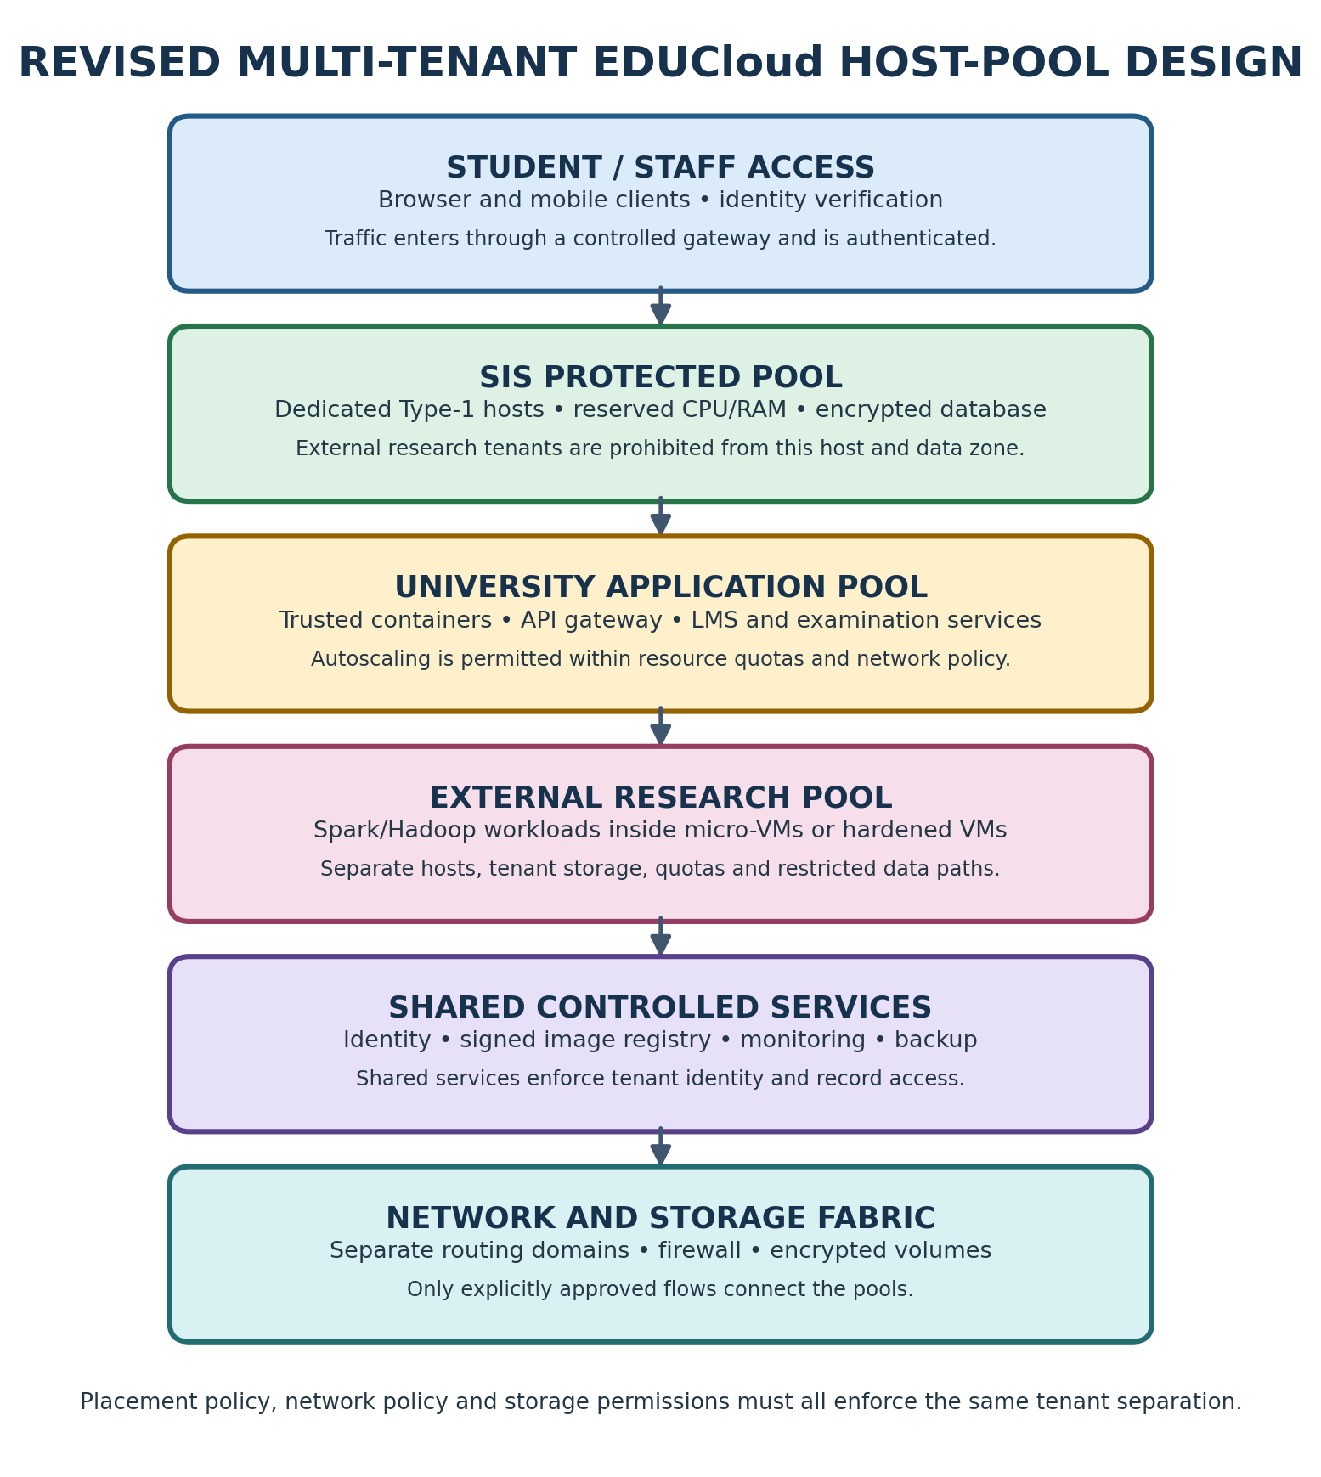
Figure: Detailed colour-coded architecture illustration.

APPENDIX Z – MULTI-TENANT DATA ISOLATION
Multi-tenancy allows several departments or organizations to use the same cloud platform while keeping their data and operations separated. Isolation must cover compute, memory, storage, network, identity, management and backup systems. A tenant boundary that exists only in the application interface is insufficient if the underlying storage or network allows cross-tenant access.
For SIS, student records should be protected by a dedicated host pool, separate database identities, tenant-aware application authorization and encrypted storage. External research collaborators should receive a separate pool and access only to approved datasets. Any shared service should enforce identity and authorization at every request.
Storage isolation can use separate volumes, namespaces, encryption keys and access policies. Network isolation can use separate routing domains, overlays and firewall rules. Compute isolation can use dedicated hosts or strong VM boundaries. Management-plane access should be restricted so one tenant cannot create, inspect or copy another tenant's resources.
Demonstrable isolation requires evidence. Keep configuration exports, host placement records, access logs, network-policy tests, encryption status and periodic audit results. Test negative cases, such as an external tenant attempting to access a protected SIS endpoint. The expected result is a logged denial.
The design should also define how data is deleted when a collaborator's project ends, including snapshots, temporary storage and backups.

Worked example and practical interpretation
Worked interpretation: With the 10% reserve, the usable planning amount is 460.8 GB. At 8 GB average resident demand, 57 VMs use 456 GB and leave 4.8 GB of the planned usable pool. The 58th VM would require 464 GB and exceed that planning amount. This arithmetic is intentionally conservative; actual placement must also account for VM reservations, host overhead, workload peaks and NUMA layout.

Design implications for EduCloud
Operational decision: Separate configured memory from active working set. A VM configured with 16 GB may use 5 GB during a quiet period but need much more during a report or batch job. Research jobs should declare memory requests and limits. Database workloads should receive sufficient reserved memory to avoid repeated disk reads and should not depend on host swapping for normal operation.

Validation, monitoring and evidence
Validation: Record available memory, working set, major page faults, swap activity, balloon activity and out-of-memory events during the same workload. If memory pressure rises, reduce admission, move workloads to a suitable pool or increase capacity; do not treat ballooning and swapping as free extra RAM.

Practical checklist for the university cloud team
Before approving this component, the cloud team should record its owner, purpose, data classification, tenant boundary, resource request, permitted dependencies and recovery requirement. The configuration should be stored in version control and reviewed before deployment. Administrators should test both normal operation and failure conditions, including a denied cross-tenant request, resource exhaustion, host maintenance and restoration from backup. Results should include timestamps, software versions, configuration values and the exact test procedure. Any limitation must be stated clearly so that an analytical assumption is not mistaken for an observed production result.

APPENDIX AA – SPARK/HADOOP WORKLOAD CHARACTERISTICS
Spark and Hadoop workloads process large datasets across multiple workers. Their performance depends on CPU, memory, disk throughput and network communication. Jobs may read large files, shuffle intermediate data between workers, spill data to disk and run for hours. Their resource demand is therefore different from short interactive SIS requests.
A long-running batch job can keep CPU and storage busy for an extended period. During a shuffle phase, network traffic can rise sharply. If the research cluster shares storage and NIC queues with SIS, the analytics workload can increase database latency and delay authentication requests.
The research pool should use separate hosts or a controlled resource pool, tenant-specific storage and restricted network paths. Apply per-job CPU, memory and I/O quotas. Schedule large jobs away from registration peaks where practical. Monitor shuffle traffic, disk spill, worker memory and job completion time.
External datasets should be classified before being made available to collaborators. Student records must not be copied into research workspaces unless there is a lawful, approved and appropriately protected purpose. Use de-identified or synthetic datasets when possible.
The research platform should expose approved data through controlled interfaces rather than giving collaborators broad access to SIS databases or shared storage.

Worked example and practical interpretation
Worked interpretation: Suppose a host exposes 256 vCPUs at a 4:1 ratio. This is a configuration count, not a promise that 256 physical cores exist. If all 256 vCPUs become runnable together, they must share the 64 physical cores. The resulting waiting time can increase application response time even when the configured vCPU count appears generous. For the SIS login and registration path, a short period of CPU contention can create request timeouts and retries, which can increase load further.

Design implications for EduCloud
Operational decision: Use reservations and conservative overcommit for the database, identity service and other latency-sensitive components. Batch analytics can use lower-priority shares or queued execution when the host is busy. Review CPU ready/steal time together with application p95 latency; high CPU utilization alone does not prove that the scheduler is the bottleneck.

Validation, monitoring and evidence
Validation: Run the same CPU workload at each planned overcommit ratio. Record throughput, p95 completion time, host CPU utilization and ready/steal time. Repeat at least five times. A placement ratio should be accepted only if the measured service objective is maintained during the expected peak, not merely during an idle demonstration.

Practical checklist for the university cloud team
Before approving this component, the cloud team should record its owner, purpose, data classification, tenant boundary, resource request, permitted dependencies and recovery requirement. The configuration should be stored in version control and reviewed before deployment. Administrators should test both normal operation and failure conditions, including a denied cross-tenant request, resource exhaustion, host maintenance and restoration from backup. Results should include timestamps, software versions, configuration values and the exact test procedure. Any limitation must be stated clearly so that an analytical assumption is not mistaken for an observed production result.

APPENDIX AB – REVISED EDUCloud ARCHITECTURE
The revised architecture separates workloads by sensitivity and trust. The SIS pool contains dedicated Type-1 hosts and protected database storage. The university application pool runs trusted web and API containers. The external research pool runs Spark/Hadoop jobs inside micro-VMs or hardened guest VMs. Shared identity, image registry, monitoring and backup services are controlled infrastructure components.
Requests enter through an authenticated gateway. The gateway validates identity, applies rate limits and forwards only authorized requests to application services. The application layer uses service identities to access databases. Database permissions enforce least privilege and tenant-aware access. Logs record the user, service, action and result without exposing unnecessary personal data.
The network separates management, storage, SIS, application and research traffic. External research workloads cannot route directly to SIS database interfaces. Data transfers use approved, authenticated paths. Storage snapshots and backups are encrypted and access-controlled.
Capacity management uses separate quotas and reservations. SIS has protected CPU and memory headroom. Research jobs have limits and may be queued or throttled when capacity is constrained. Planned migration is rate-limited and avoided during critical registration windows.
The architecture is more complex than a single shared pool, but its boundaries correspond to the university's actual trust and performance requirements.

Worked example and practical interpretation
Worked interpretation: Suppose a host exposes 256 vCPUs at a 4:1 ratio. This is a configuration count, not a promise that 256 physical cores exist. If all 256 vCPUs become runnable together, they must share the 64 physical cores. The resulting waiting time can increase application response time even when the configured vCPU count appears generous. For the SIS login and registration path, a short period of CPU contention can create request timeouts and retries, which can increase load further.

Design implications for EduCloud
Operational decision: Use reservations and conservative overcommit for the database, identity service and other latency-sensitive components. Batch analytics can use lower-priority shares or queued execution when the host is busy. Review CPU ready/steal time together with application p95 latency; high CPU utilization alone does not prove that the scheduler is the bottleneck.

Validation, monitoring and evidence
Validation: Run the same CPU workload at each planned overcommit ratio. Record throughput, p95 completion time, host CPU utilization and ready/steal time. Repeat at least five times. A placement ratio should be accepted only if the measured service objective is maintained during the expected peak, not merely during an idle demonstration.

Practical checklist for the university cloud team
Before approving this component, the cloud team should record its owner, purpose, data classification, tenant boundary, resource request, permitted dependencies and recovery requirement. The configuration should be stored in version control and reviewed before deployment. Administrators should test both normal operation and failure conditions, including a denied cross-tenant request, resource exhaustion, host maintenance and restoration from backup. Results should include timestamps, software versions, configuration values and the exact test procedure. Any limitation must be stated clearly so that an analytical assumption is not mistaken for an observed production result.

APPENDIX AC – MIGRATION AND PATCHING PLAN
Migration should be phased to reduce risk. First, inventory every VM, owner, operating system, application dependency, data classification and network connection. Identify outdated guest kernels and unsupported software. Next, create approved golden images and validate backups before changing placement.
Move non-critical departmental workloads first to validate host pools, monitoring, network policy and rollback. Then move stateless application components, which are easier to recreate. Migrate SIS components only after compatibility, data consistency and recovery tests are complete. Database migration requires application-aware validation and a tested rollback plan.
Patch hosts in controlled batches. Before maintenance, verify N+1 capacity and destination compatibility. Drain workloads from one host, migrate them securely, patch and reboot the host, then validate health before proceeding to the next. Do not drain multiple hosts if that would violate capacity headroom.
Record change approvals, source and destination hosts, VM identifiers, migration start and end times, operator identity and health checks. Encrypt migration traffic and restrict access to the migration network.
After each phase, compare application latency, error rates and resource utilization with the pre-migration baseline. Pause the rollout if the service objective degrades.

Worked example and practical interpretation
Worked interpretation: Two 25 Gbps interfaces give a nominal 50 Gbps aggregate line rate only when the network configuration and traffic distribution allow both links to carry traffic. A single TCP flow may not use both links. Overlay encapsulation, packet size, retransmissions, virtual-switch processing and CPU availability all influence usable throughput.

Design implications for EduCloud
Operational decision: Separate management, storage, SIS, application and research traffic. Use explicit tenant routing and firewall policies. Research cluster shuffle traffic should not be allowed to saturate the same queues used by login and registration services. Apply bandwidth reservations or rate limits where the platform supports them.

Validation, monitoring and evidence
Validation: Use iperf3 with documented stream count, packet size and test duration. Record throughput, retransmissions, packet drops and CPU use. Test allowed and denied tenant paths. A security test should prove that a collaborator cannot connect to an SIS database endpoint, while authorized application traffic continues to work.

Practical checklist for the university cloud team
Before approving this component, the cloud team should record its owner, purpose, data classification, tenant boundary, resource request, permitted dependencies and recovery requirement. The configuration should be stored in version control and reviewed before deployment. Administrators should test both normal operation and failure conditions, including a denied cross-tenant request, resource exhaustion, host maintenance and restoration from backup. Results should include timestamps, software versions, configuration values and the exact test procedure. Any limitation must be stated clearly so that an analytical assumption is not mistaken for an observed production result.

APPENDIX AD – MONITORING AND INCIDENT RESPONSE
Monitoring should combine infrastructure metrics with application-level indicators. Infrastructure metrics include CPU utilization, CPU ready or steal time, memory pressure, swap activity, storage IOPS, storage latency, network throughput and packet drops. Application indicators include request rate, error rate, mean latency and p95 latency. Authentication success and failure rates should be monitored separately.
Alerts should be based on sustained symptoms and service objectives rather than a single high CPU sample. For example, a rising p95 latency combined with CPU ready time and a growing run queue suggests CPU contention. High database latency with normal CPU may indicate storage or locking problems.
Security monitoring should capture privileged login events, image downloads, snapshot exports, network-policy changes, VM placement changes, failed access attempts and unusual data transfers. Logs should be protected from alteration and retained according to university policy.
An incident response playbook should define who can isolate a workload, disable credentials, block network access, preserve evidence, restore from trusted images and communicate with affected stakeholders. A suspected tenant escape or unauthorized SIS access should trigger immediate containment and investigation.
Run periodic exercises. A recovery procedure that has never been tested may fail during a real incident.

Worked example and practical interpretation
Worked interpretation: Suppose a host exposes 256 vCPUs at a 4:1 ratio. This is a configuration count, not a promise that 256 physical cores exist. If all 256 vCPUs become runnable together, they must share the 64 physical cores. The resulting waiting time can increase application response time even when the configured vCPU count appears generous. For the SIS login and registration path, a short period of CPU contention can create request timeouts and retries, which can increase load further.

Design implications for EduCloud
Operational decision: Use reservations and conservative overcommit for the database, identity service and other latency-sensitive components. Batch analytics can use lower-priority shares or queued execution when the host is busy. Review CPU ready/steal time together with application p95 latency; high CPU utilization alone does not prove that the scheduler is the bottleneck.

Validation, monitoring and evidence
Validation: Run the same CPU workload at each planned overcommit ratio. Record throughput, p95 completion time, host CPU utilization and ready/steal time. Repeat at least five times. A placement ratio should be accepted only if the measured service objective is maintained during the expected peak, not merely during an idle demonstration.

Practical checklist for the university cloud team
Before approving this component, the cloud team should record its owner, purpose, data classification, tenant boundary, resource request, permitted dependencies and recovery requirement. The configuration should be stored in version control and reviewed before deployment. Administrators should test both normal operation and failure conditions, including a denied cross-tenant request, resource exhaustion, host maintenance and restoration from backup. Results should include timestamps, software versions, configuration values and the exact test procedure. Any limitation must be stated clearly so that an analytical assumption is not mistaken for an observed production result.

APPENDIX AE – VALIDATION CHECKLIST AND FINAL DESIGN REVIEW
Before accepting the revised EduCloud design, validate that each workload is placed in the correct pool and that placement cannot be bypassed by ordinary tenant users. Confirm that SIS hosts have reserved capacity and that external collaborators cannot access SIS storage or network endpoints.
Validate image provenance by deploying only signed, approved images. Confirm that outdated guest kernels are identified and patched. Check that container workloads are not privileged and that cgroup limits are active. Verify that sandbox or micro-VM workloads use the intended runtime and configuration.
Run CPU, memory, disk and network benchmarks at the planned instance counts. Perform a noisy-neighbour test and confirm that SIS latency remains within the agreed target. Test migration with encrypted channels and observe the effect on application performance. Test host failure and confirm that the remaining pool can carry critical services.
Record the configuration, test procedure, result, date, operator and evidence location. Distinguish passed tests from tests that were not run. If the result is inconclusive, state what additional evidence is required.
The final architecture should be reviewed whenever the number of tenants, workload type, data sensitivity or availability target changes. Cloud architecture is an operating practice, not a one-time diagram.

Worked example and practical interpretation
Worked interpretation: Suppose a host exposes 256 vCPUs at a 4:1 ratio. This is a configuration count, not a promise that 256 physical cores exist. If all 256 vCPUs become runnable together, they must share the 64 physical cores. The resulting waiting time can increase application response time even when the configured vCPU count appears generous. For the SIS login and registration path, a short period of CPU contention can create request timeouts and retries, which can increase load further.

Design implications for EduCloud
Operational decision: Use reservations and conservative overcommit for the database, identity service and other latency-sensitive components. Batch analytics can use lower-priority shares or queued execution when the host is busy. Review CPU ready/steal time together with application p95 latency; high CPU utilization alone does not prove that the scheduler is the bottleneck.

Validation, monitoring and evidence
Validation: Run the same CPU workload at each planned overcommit ratio. Record throughput, p95 completion time, host CPU utilization and ready/steal time. Repeat at least five times. A placement ratio should be accepted only if the measured service objective is maintained during the expected peak, not merely during an idle demonstration.

Practical checklist for the university cloud team
Before approving this component, the cloud team should record its owner, purpose, data classification, tenant boundary, resource request, permitted dependencies and recovery requirement. The configuration should be stored in version control and reviewed before deployment. Administrators should test both normal operation and failure conditions, including a denied cross-tenant request, resource exhaustion, host maintenance and restoration from backup. Results should include timestamps, software versions, configuration values and the exact test procedure. Any limitation must be stated clearly so that an analytical assumption is not mistaken for an observed production result.

EXPERIMENTAL EVIDENCE STATUS AND SUBMISSION GUIDANCE
This report contains expanded explanations, calculations, design decisions, colour-coded diagrams and a reproducible testing procedure. It does not claim that laboratory experiments have been executed. Actual measurements, screenshots, graphs and terminal logs must be added after running the tests in an authorized lab.
The colour in the diagrams distinguishes architectural layers, trust boundaries and traffic zones. The report's written matter, tables, headings and page backgrounds remain black and white to preserve the requested assignment style.
Before submission, verify student details, add the actual submission date, execute the practical tests, insert genuine screenshots, complete the measurement tables and compare the observed results with the analytical model.

